***Use this word document to describe all your steps after each problem. Show all commands & screen pages and describe your steps. Points are deducted for missing steps.***

Describe all steps for each problem set and capture screen shots for each step with a JPG image within this document. Do not forget to put your name on the top of this file for your submitted homework. Also, please replace _ALL_ text in red with your information! Please include in your MS Word document only relevant portions of the console output or output files. Sometime either console output or the result file is too long and including it into the MS Word document makes that document too hard to read. PLEASE DO NOT EMBED files into your MS Word document. You are not obliged to use Java or Eclipse. You are welcome to use any language and any IDE of your choice.

**Problem 1:**

Download and Install Neo4j database onto your computer

**Total points: 10**

Download NEO4j from: <https://neo4j.com/download/>



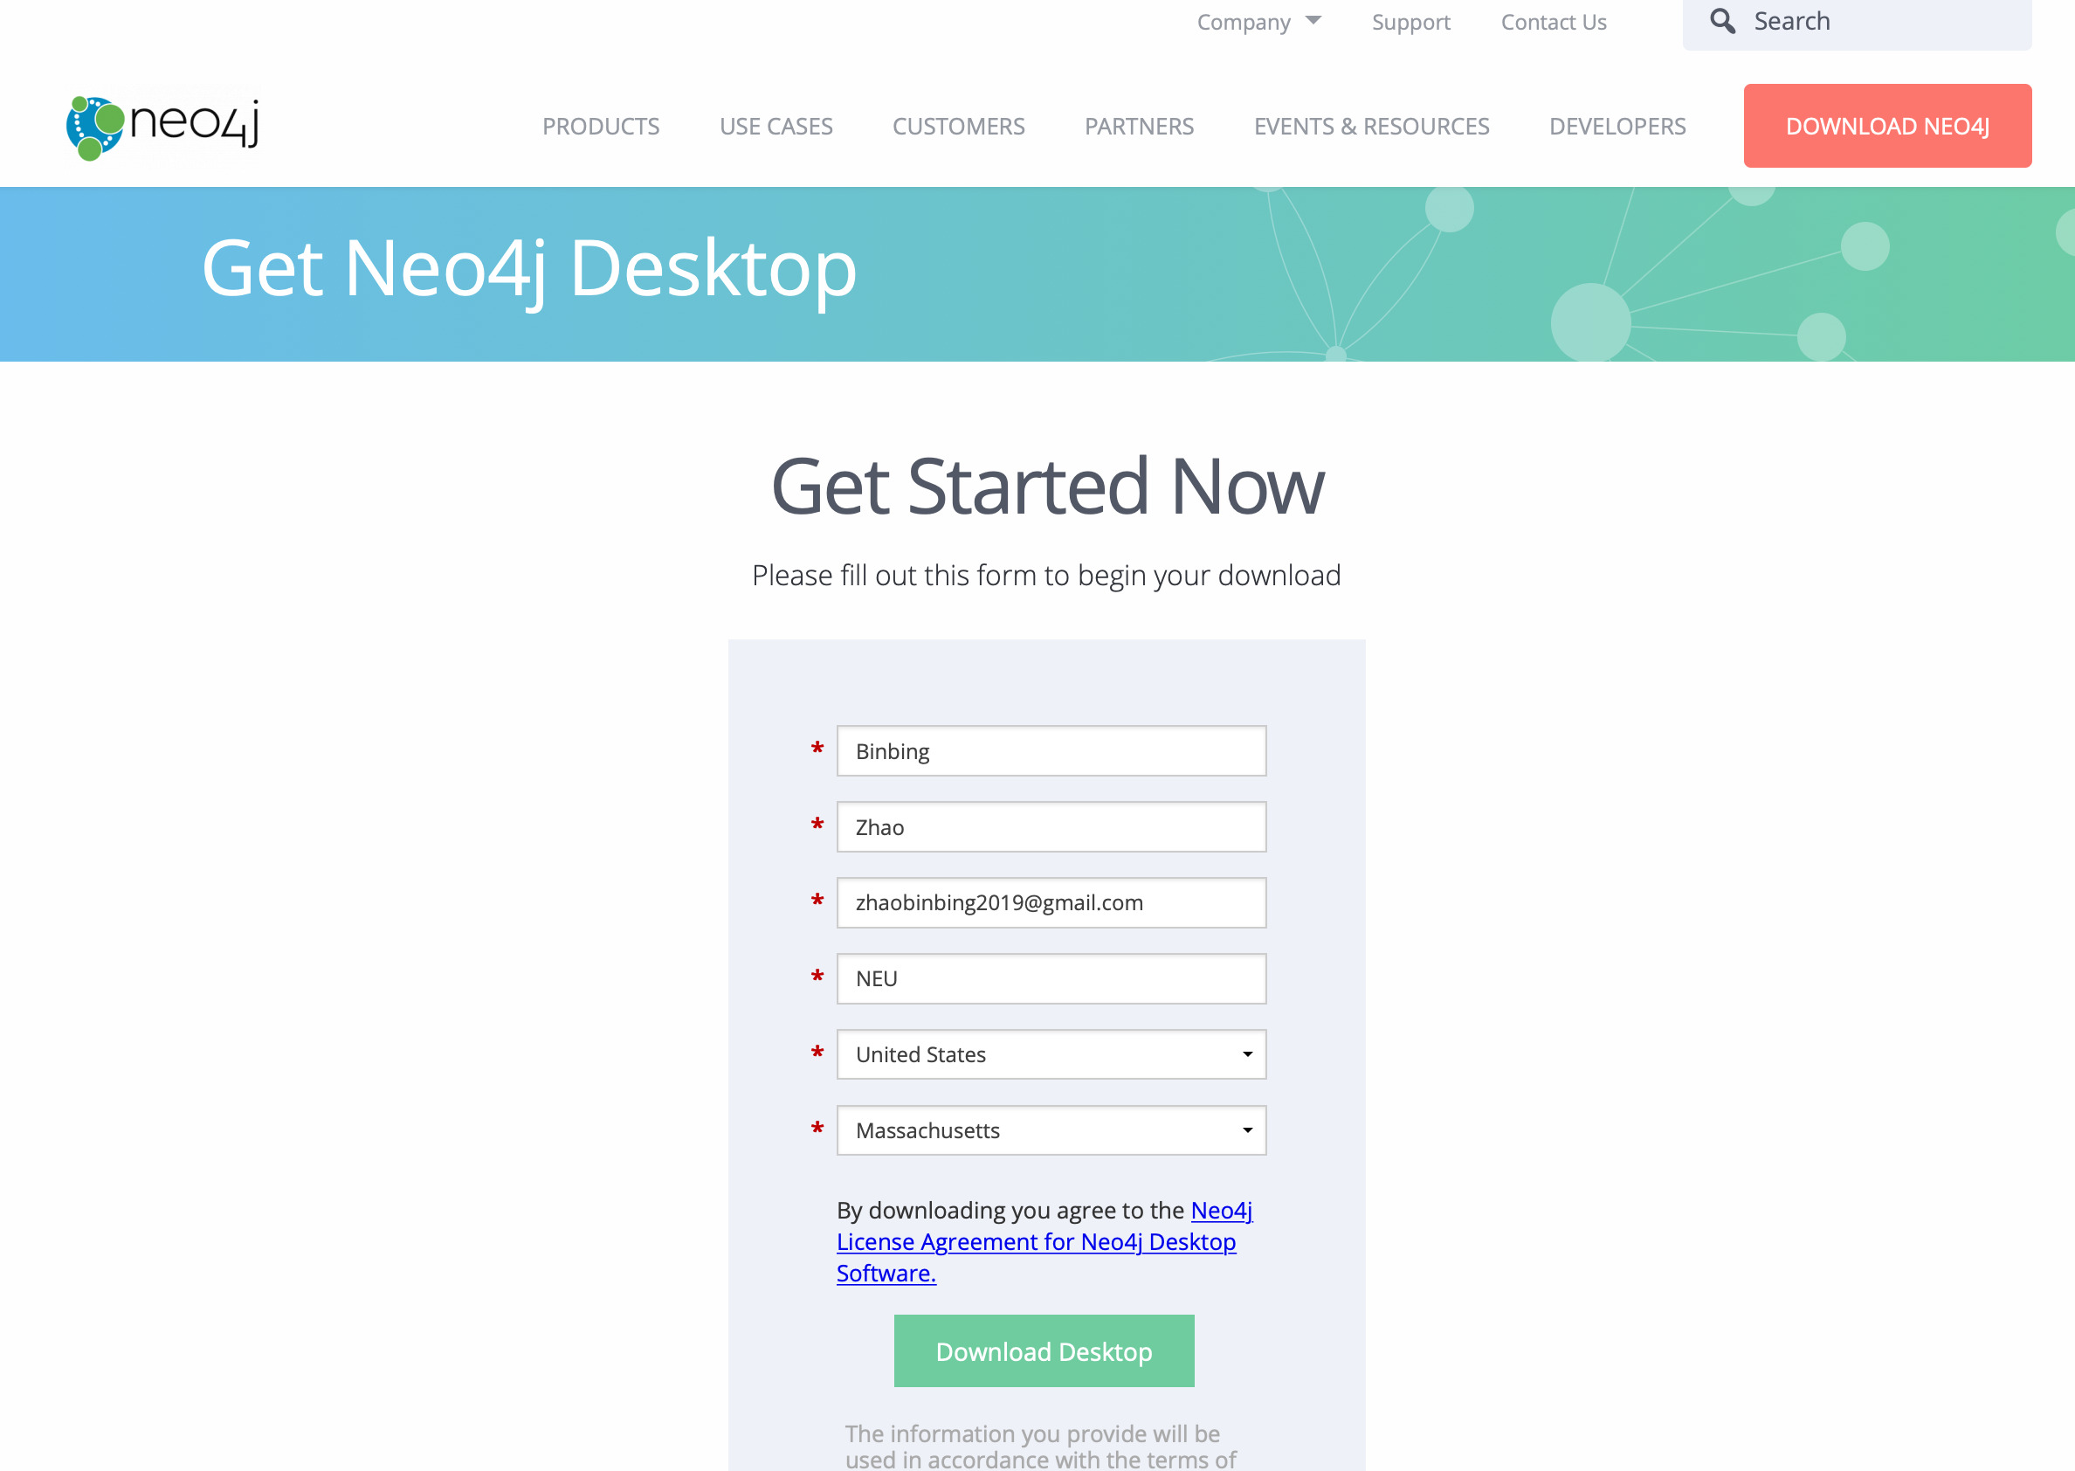

Enter your information for activation key, and then copy the key. (don’t use chrome, use safari for the automated downloading)

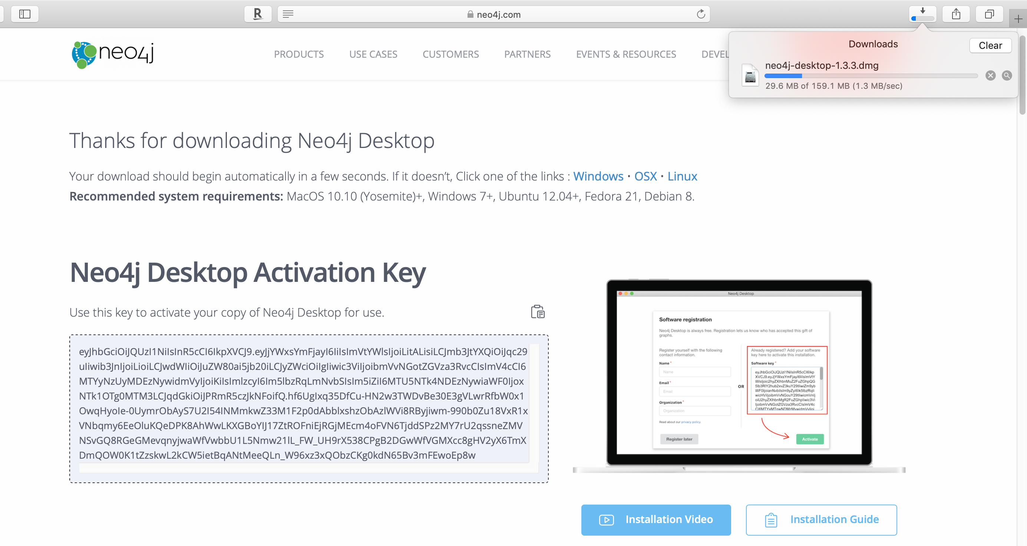

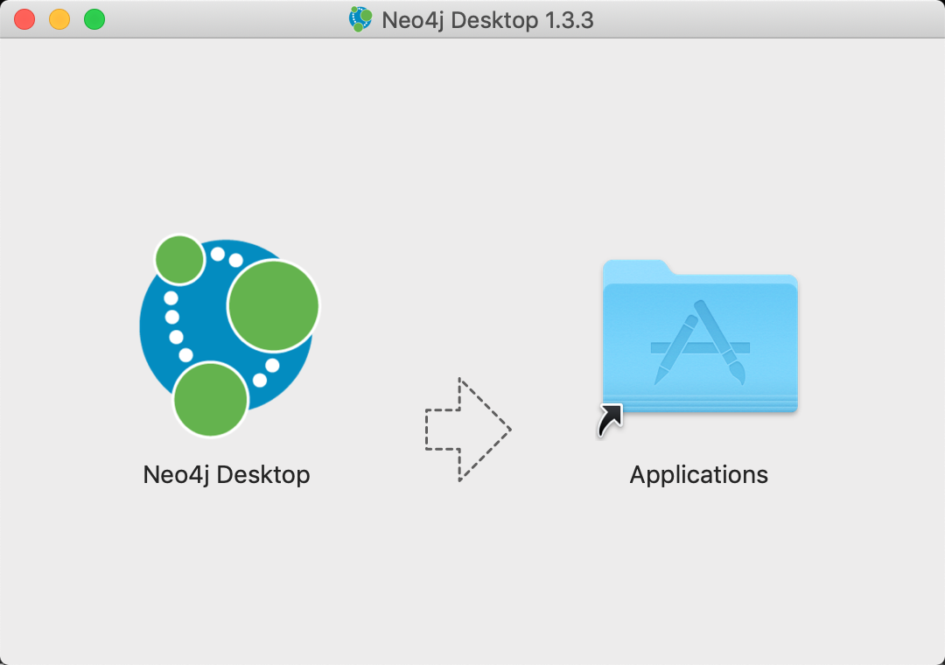

Double click the install package on your Mac

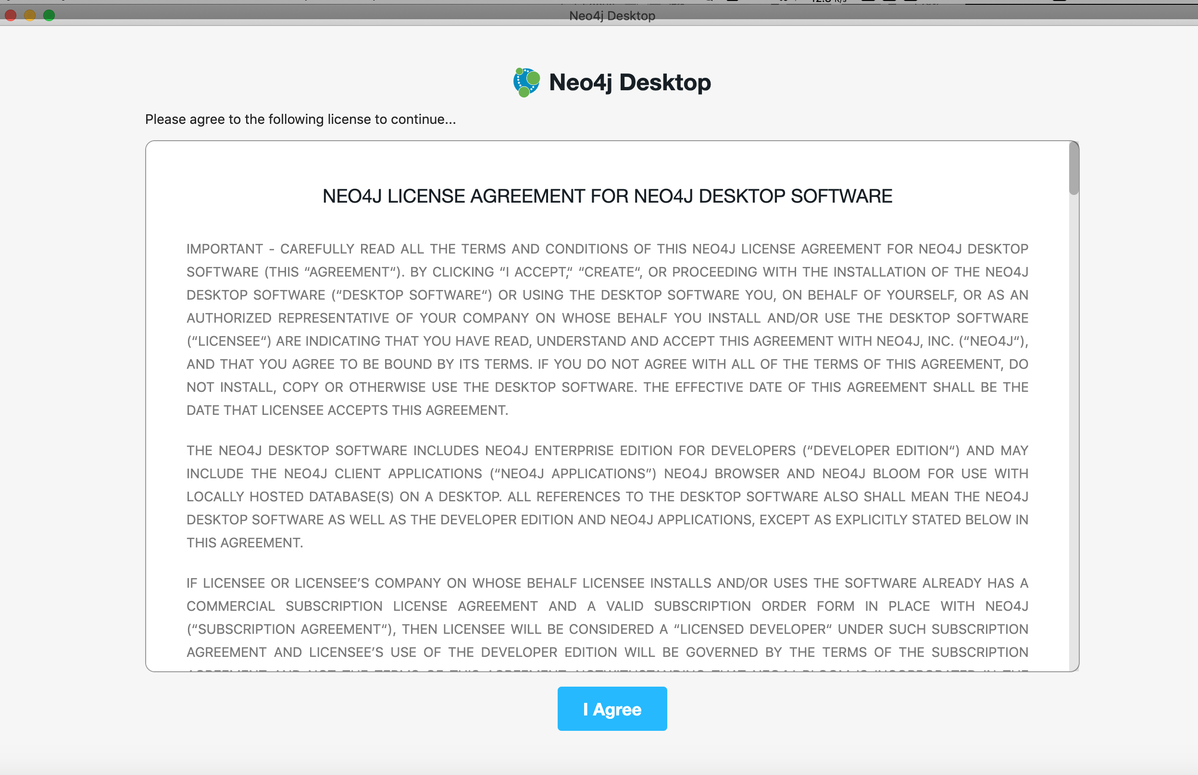

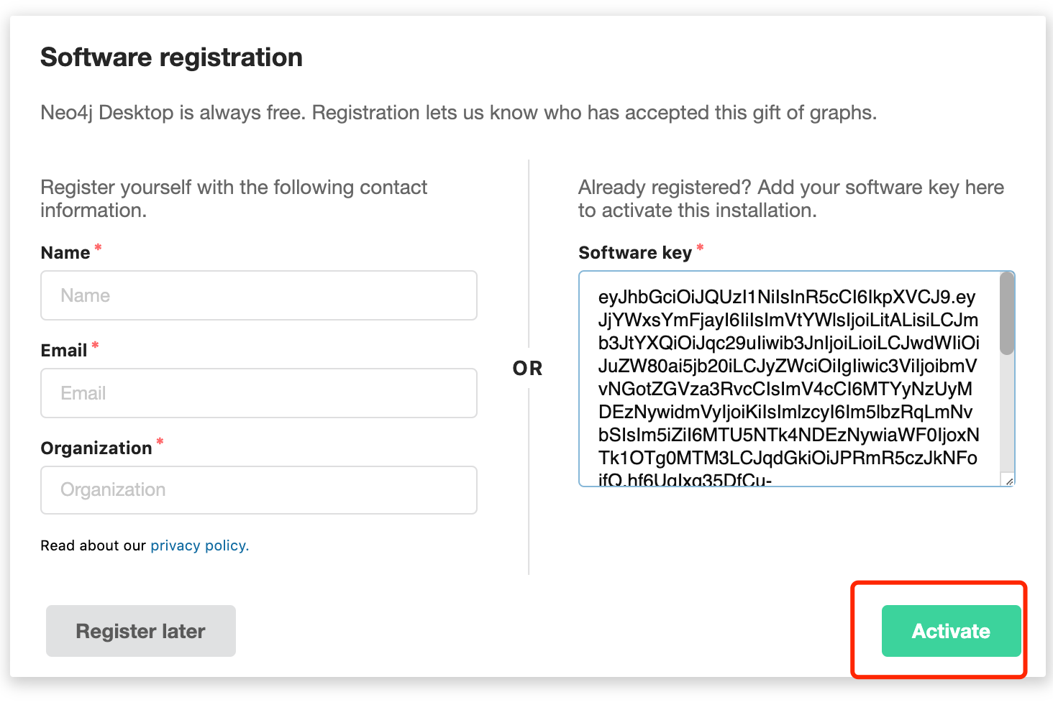

Then enter the activation key for the installation:

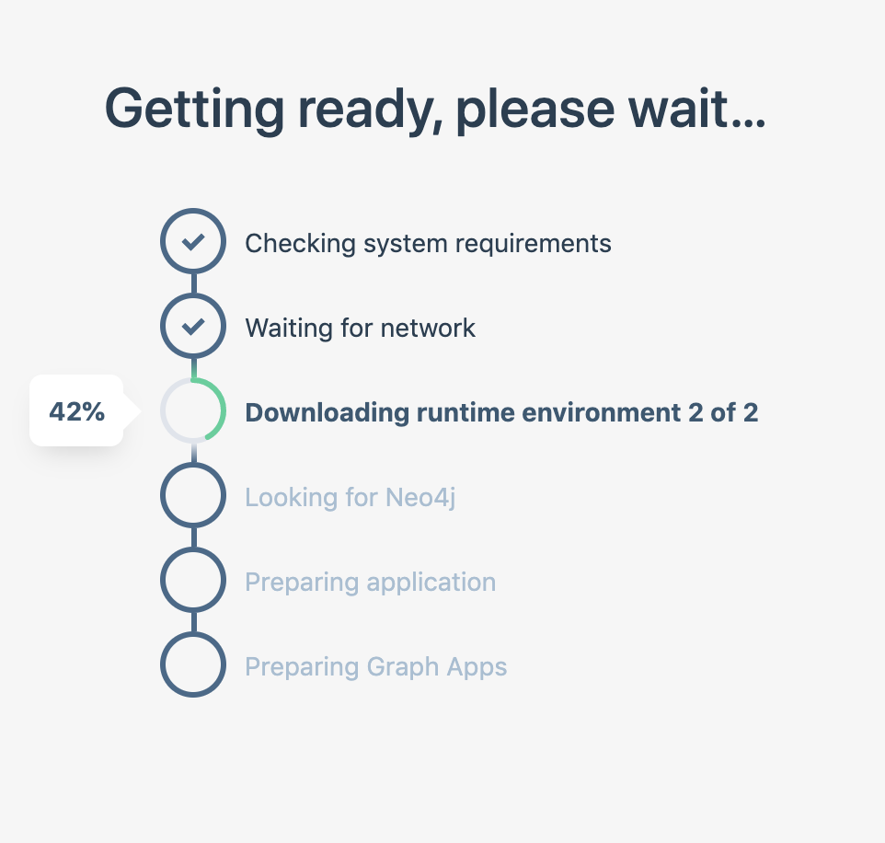

i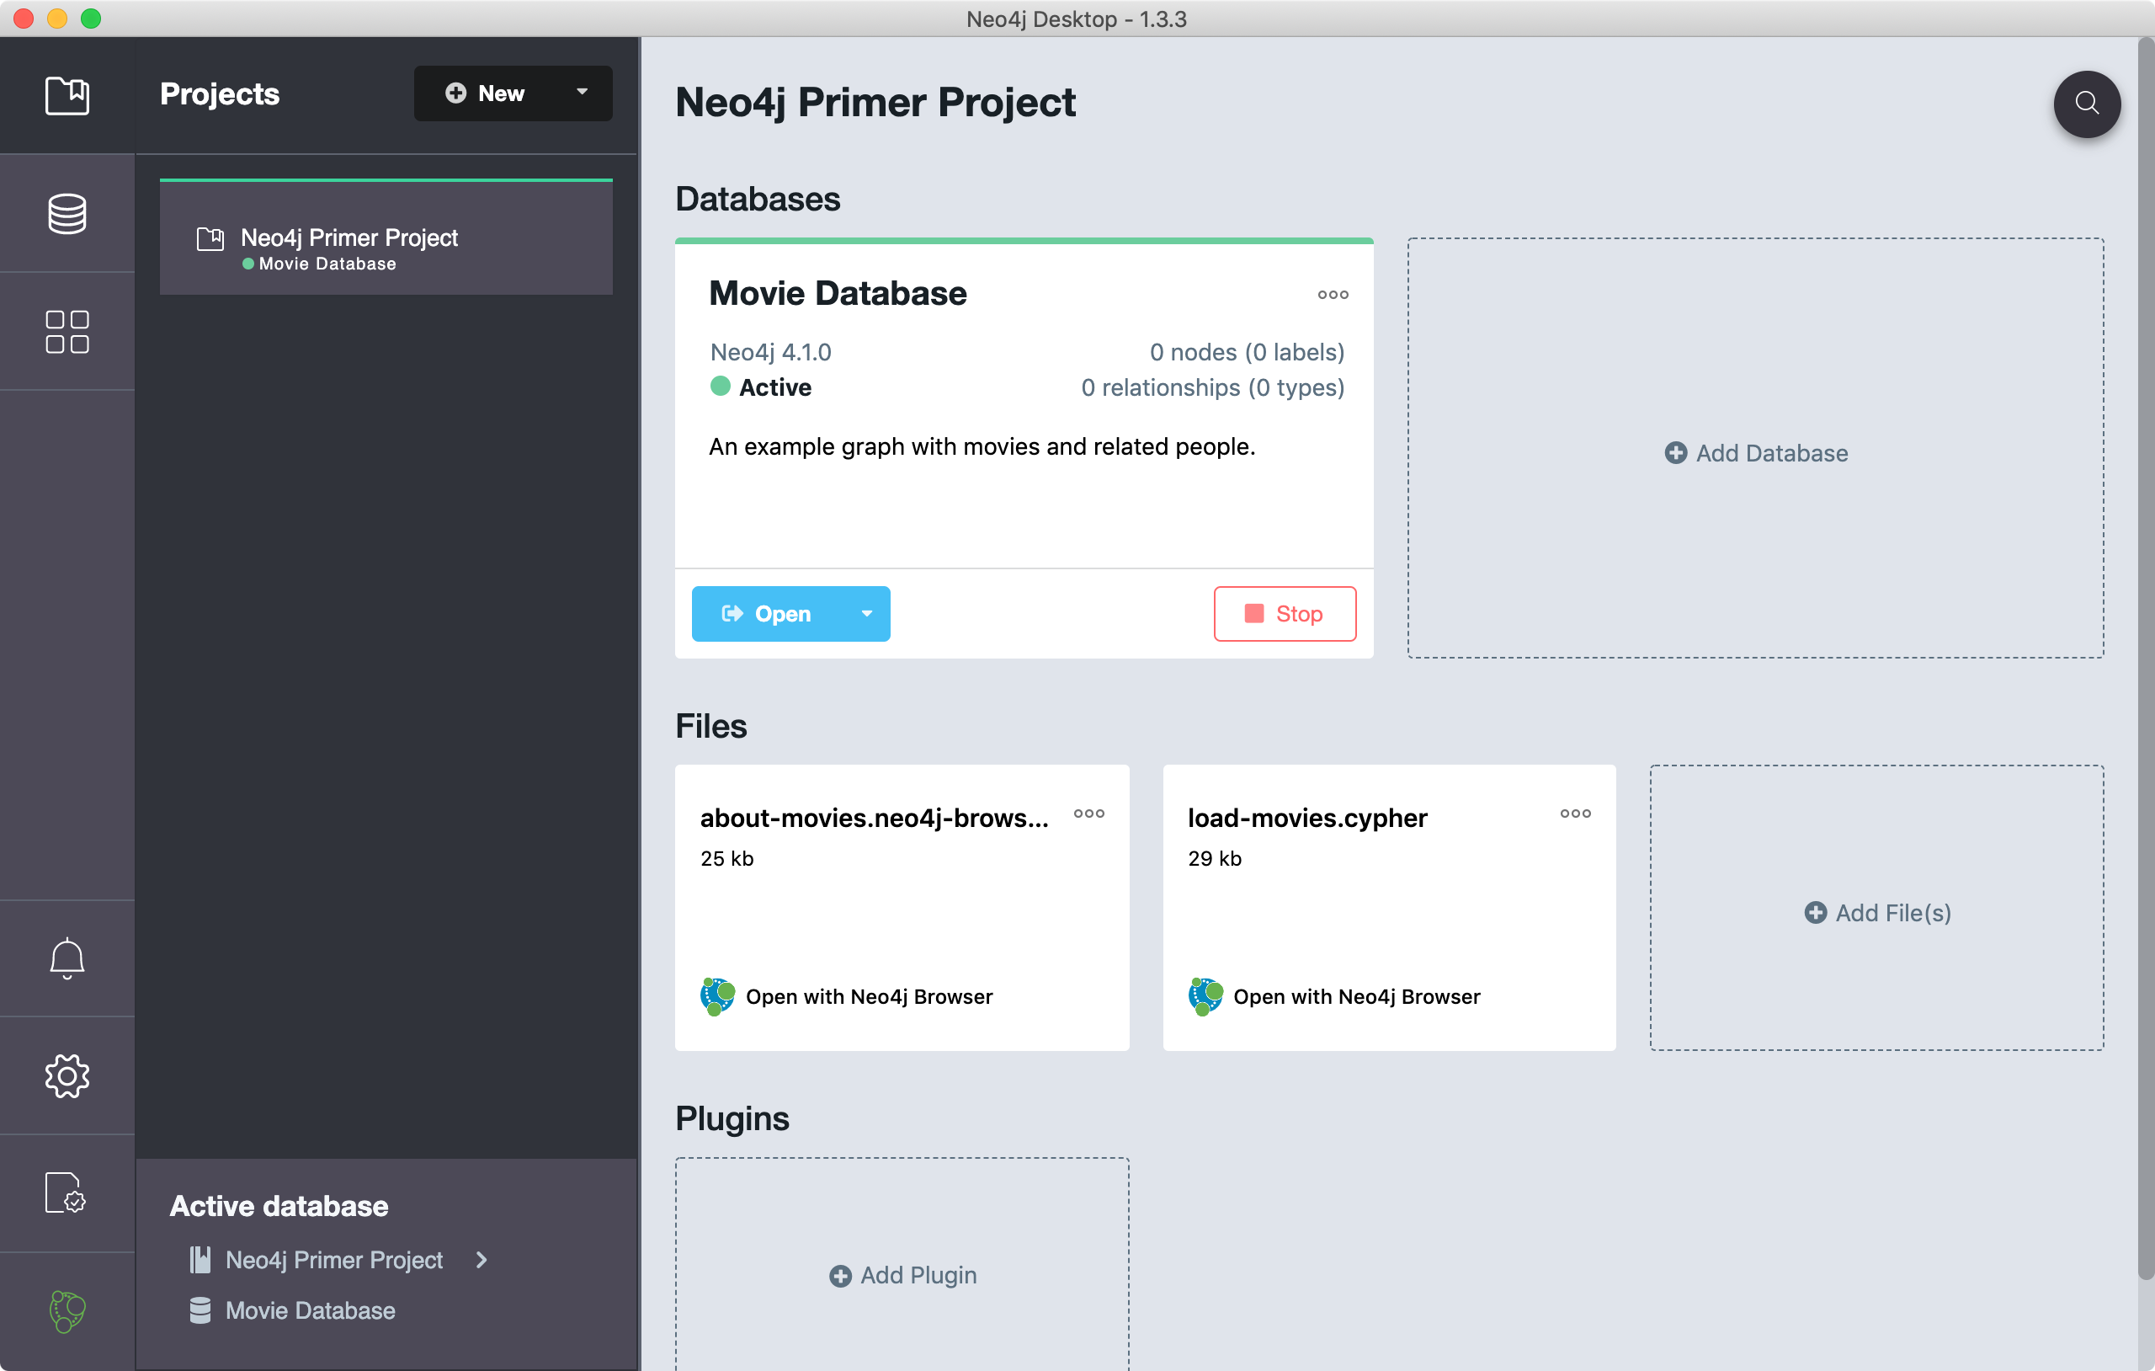

Done. Open the Neo4j 1.3.3 on the desktop.



**Problem 2:**

The following is the content of Movies database. Bring that database into Neo4J using curl.

CREATE (matrix1:Movie { title : 'The Matrix', year : '1999-03-31' })

CREATE (matrix2:Movie { title : 'The Matrix Reloaded', year : '2003-05-07' })

CREATE (matrix3:Movie { title : 'The Matrix Revolutions', year : '2003-10-27' })

CREATE (keanu:Actor { name:'Keanu Reeves' })

CREATE (laurence:Actor { name:'Laurence Fishburne' })

CREATE (carrieanne:Actor { name:'Carrie-Anne Moss' })

CREATE (keanu)-[:ACTS_IN { role : 'Neo' }]->(matrix1)

CREATE (keanu)-[:ACTS_IN { role : 'Neo' }]->(matrix2)

CREATE (keanu)-[:ACTS_IN { role : 'Neo' }]->(matrix3)

CREATE (laurence)-[:ACTS_IN { role : 'Morpheus' }]->(matrix1)

CREATE (laurence)-[:ACTS_IN { role : 'Morpheus' }]->(matrix2)

CREATE (laurence)-[:ACTS_IN { role : 'Morpheus' }]->(matrix3)

CREATE (carrieanne)-[:ACTS_IN { role : 'Trinity' }]->(matrix1)

CREATE (carrieanne)-[:ACTS_IN { role : 'Trinity' }]->(matrix2)

CREATE (carrieanne)-[:ACTS_IN { role : 'Trinity' }]->(matrix3)

**Total points: 20**

Put all your steps and screen captures here.

Try the original “Movie Database”

Install the Movies dataset with :play movies:

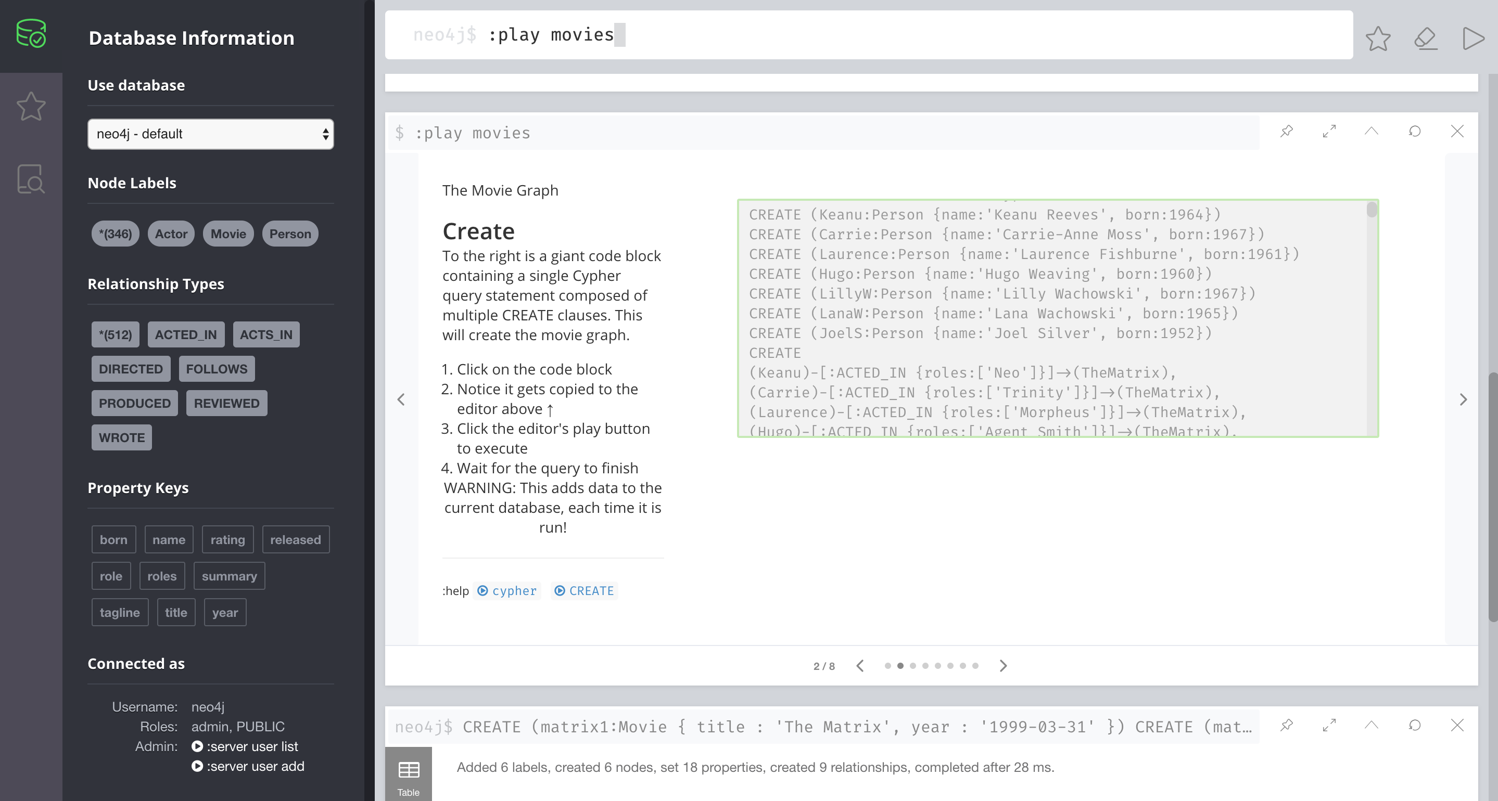

Click the large CREATE statement and hit the triangular “Run” button to insert the data

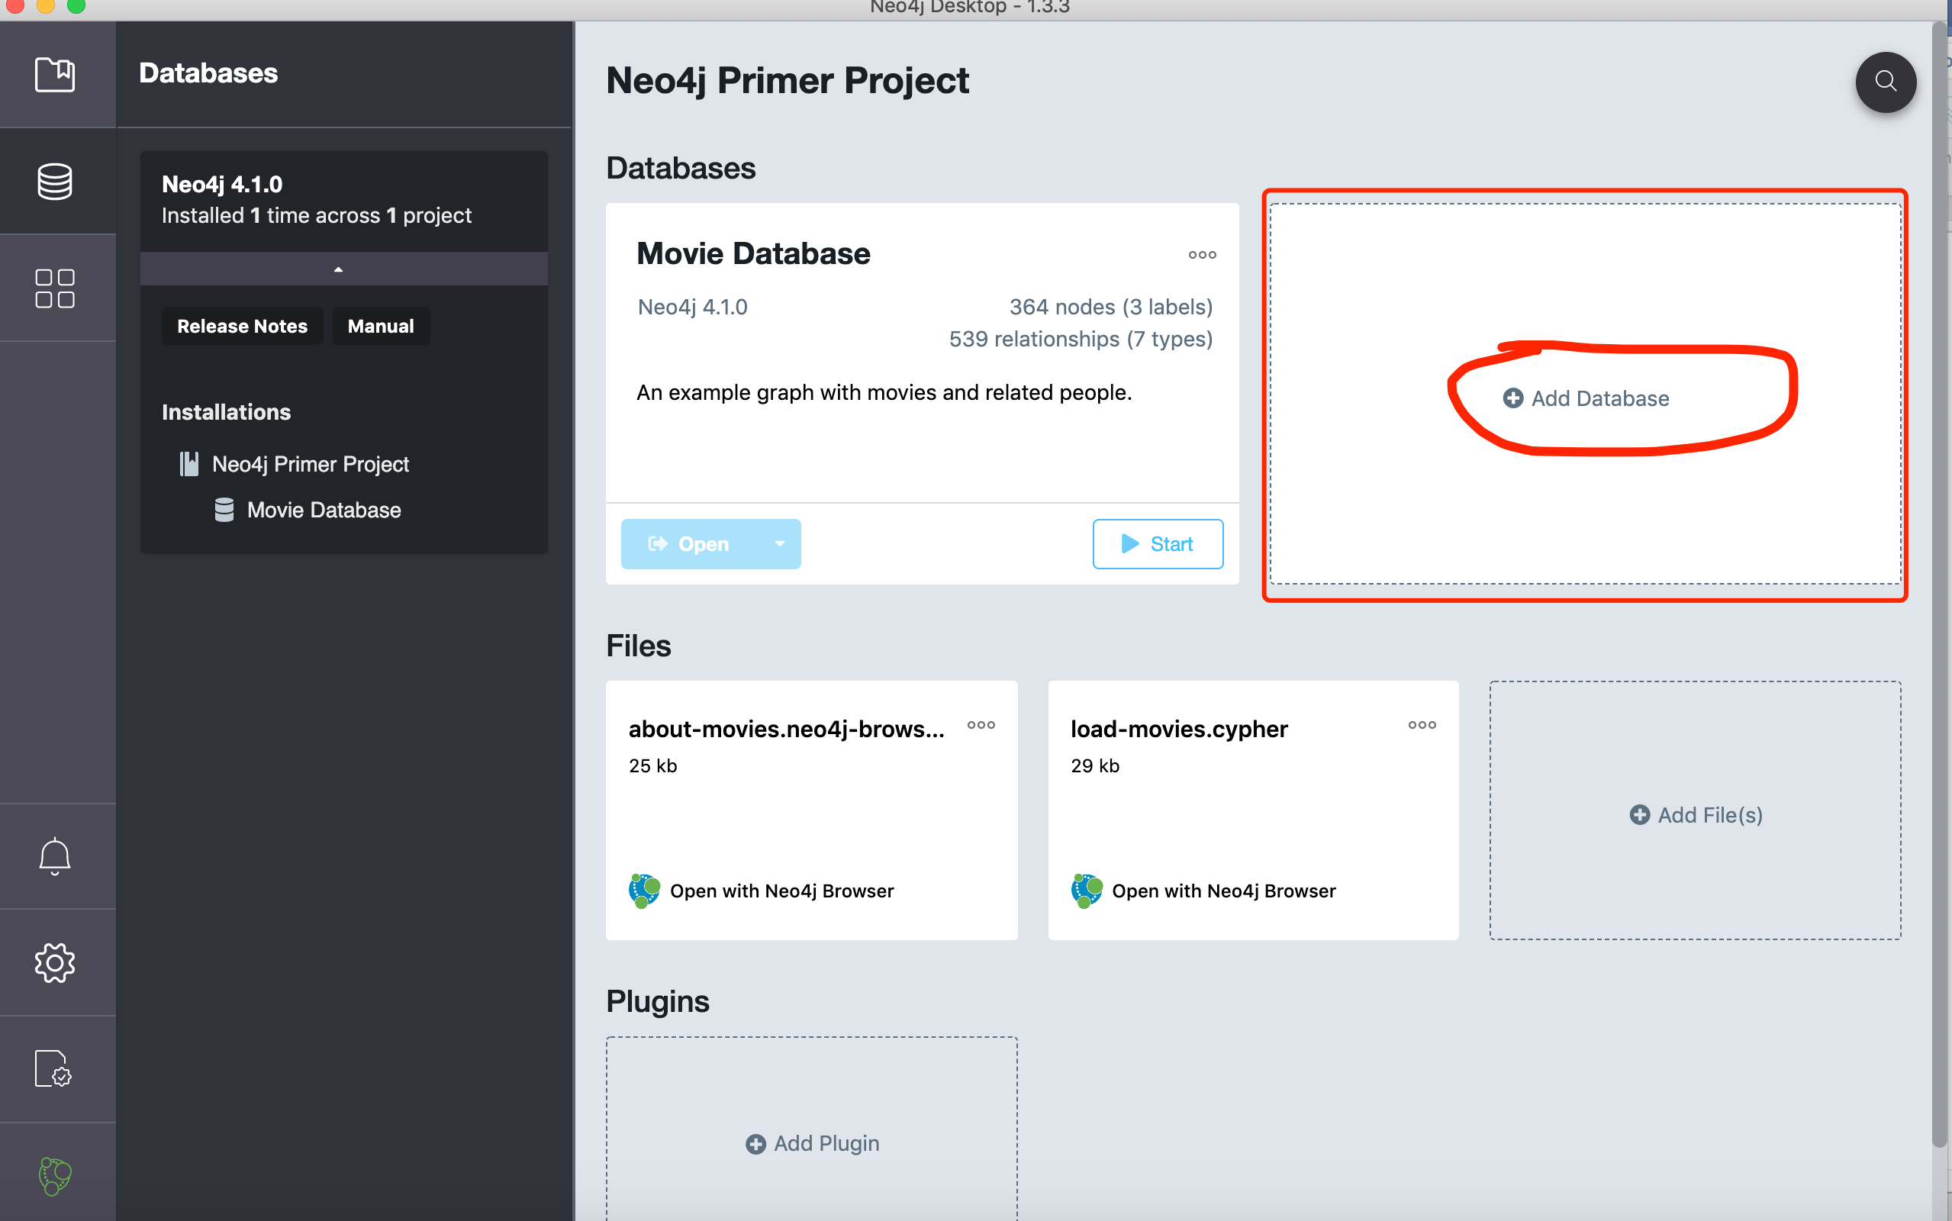

Create a new graph database↑

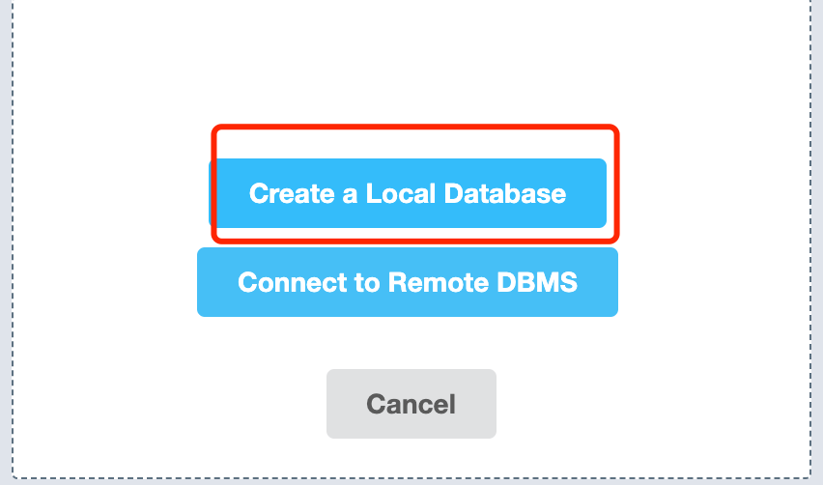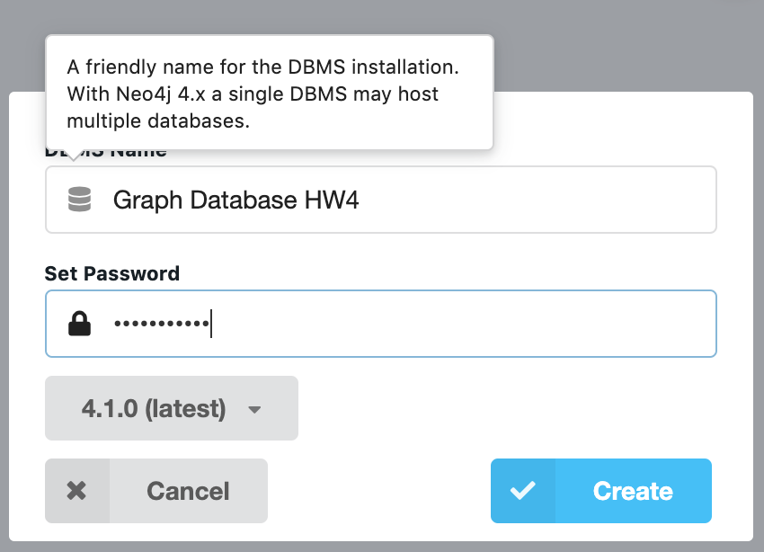’ 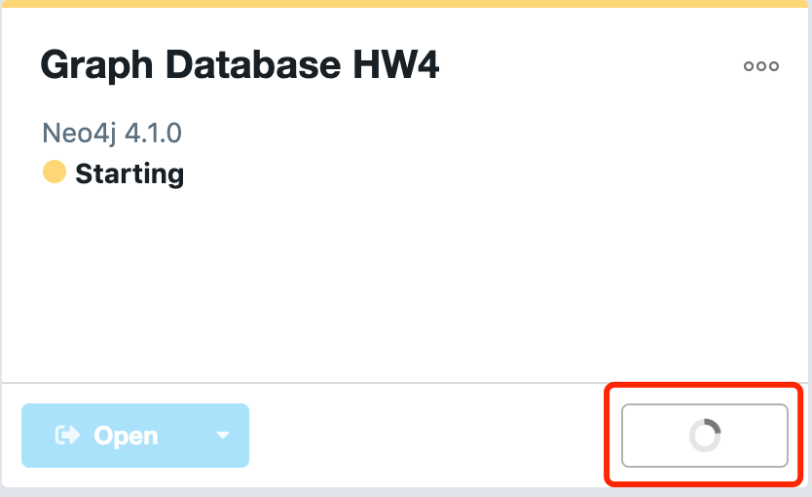

Open the new graph database

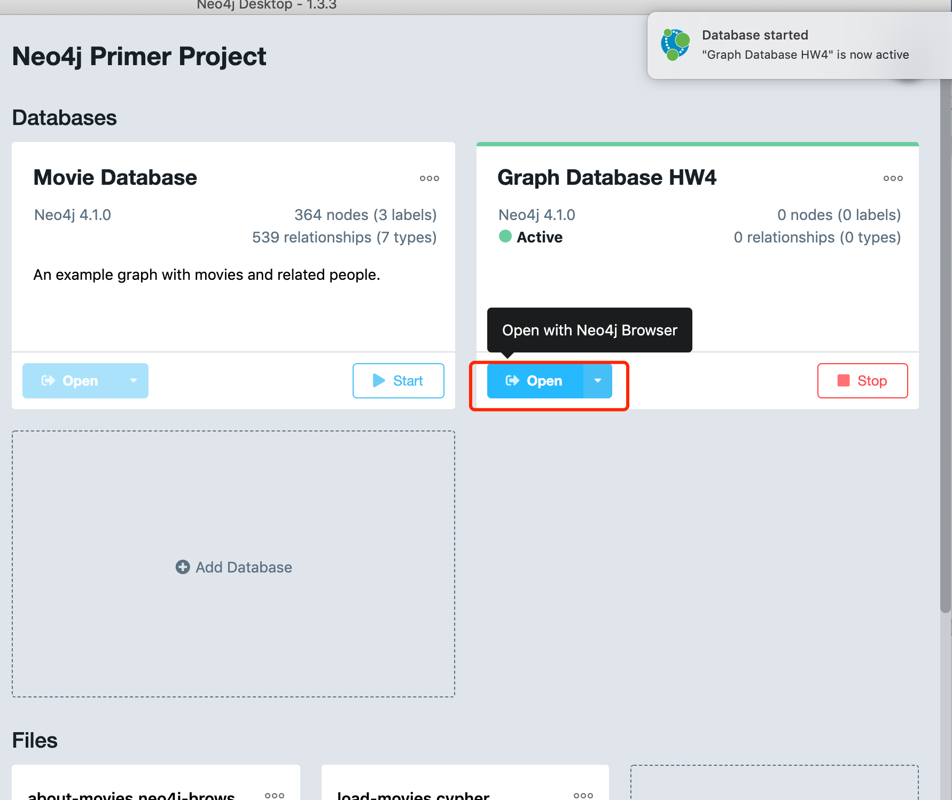

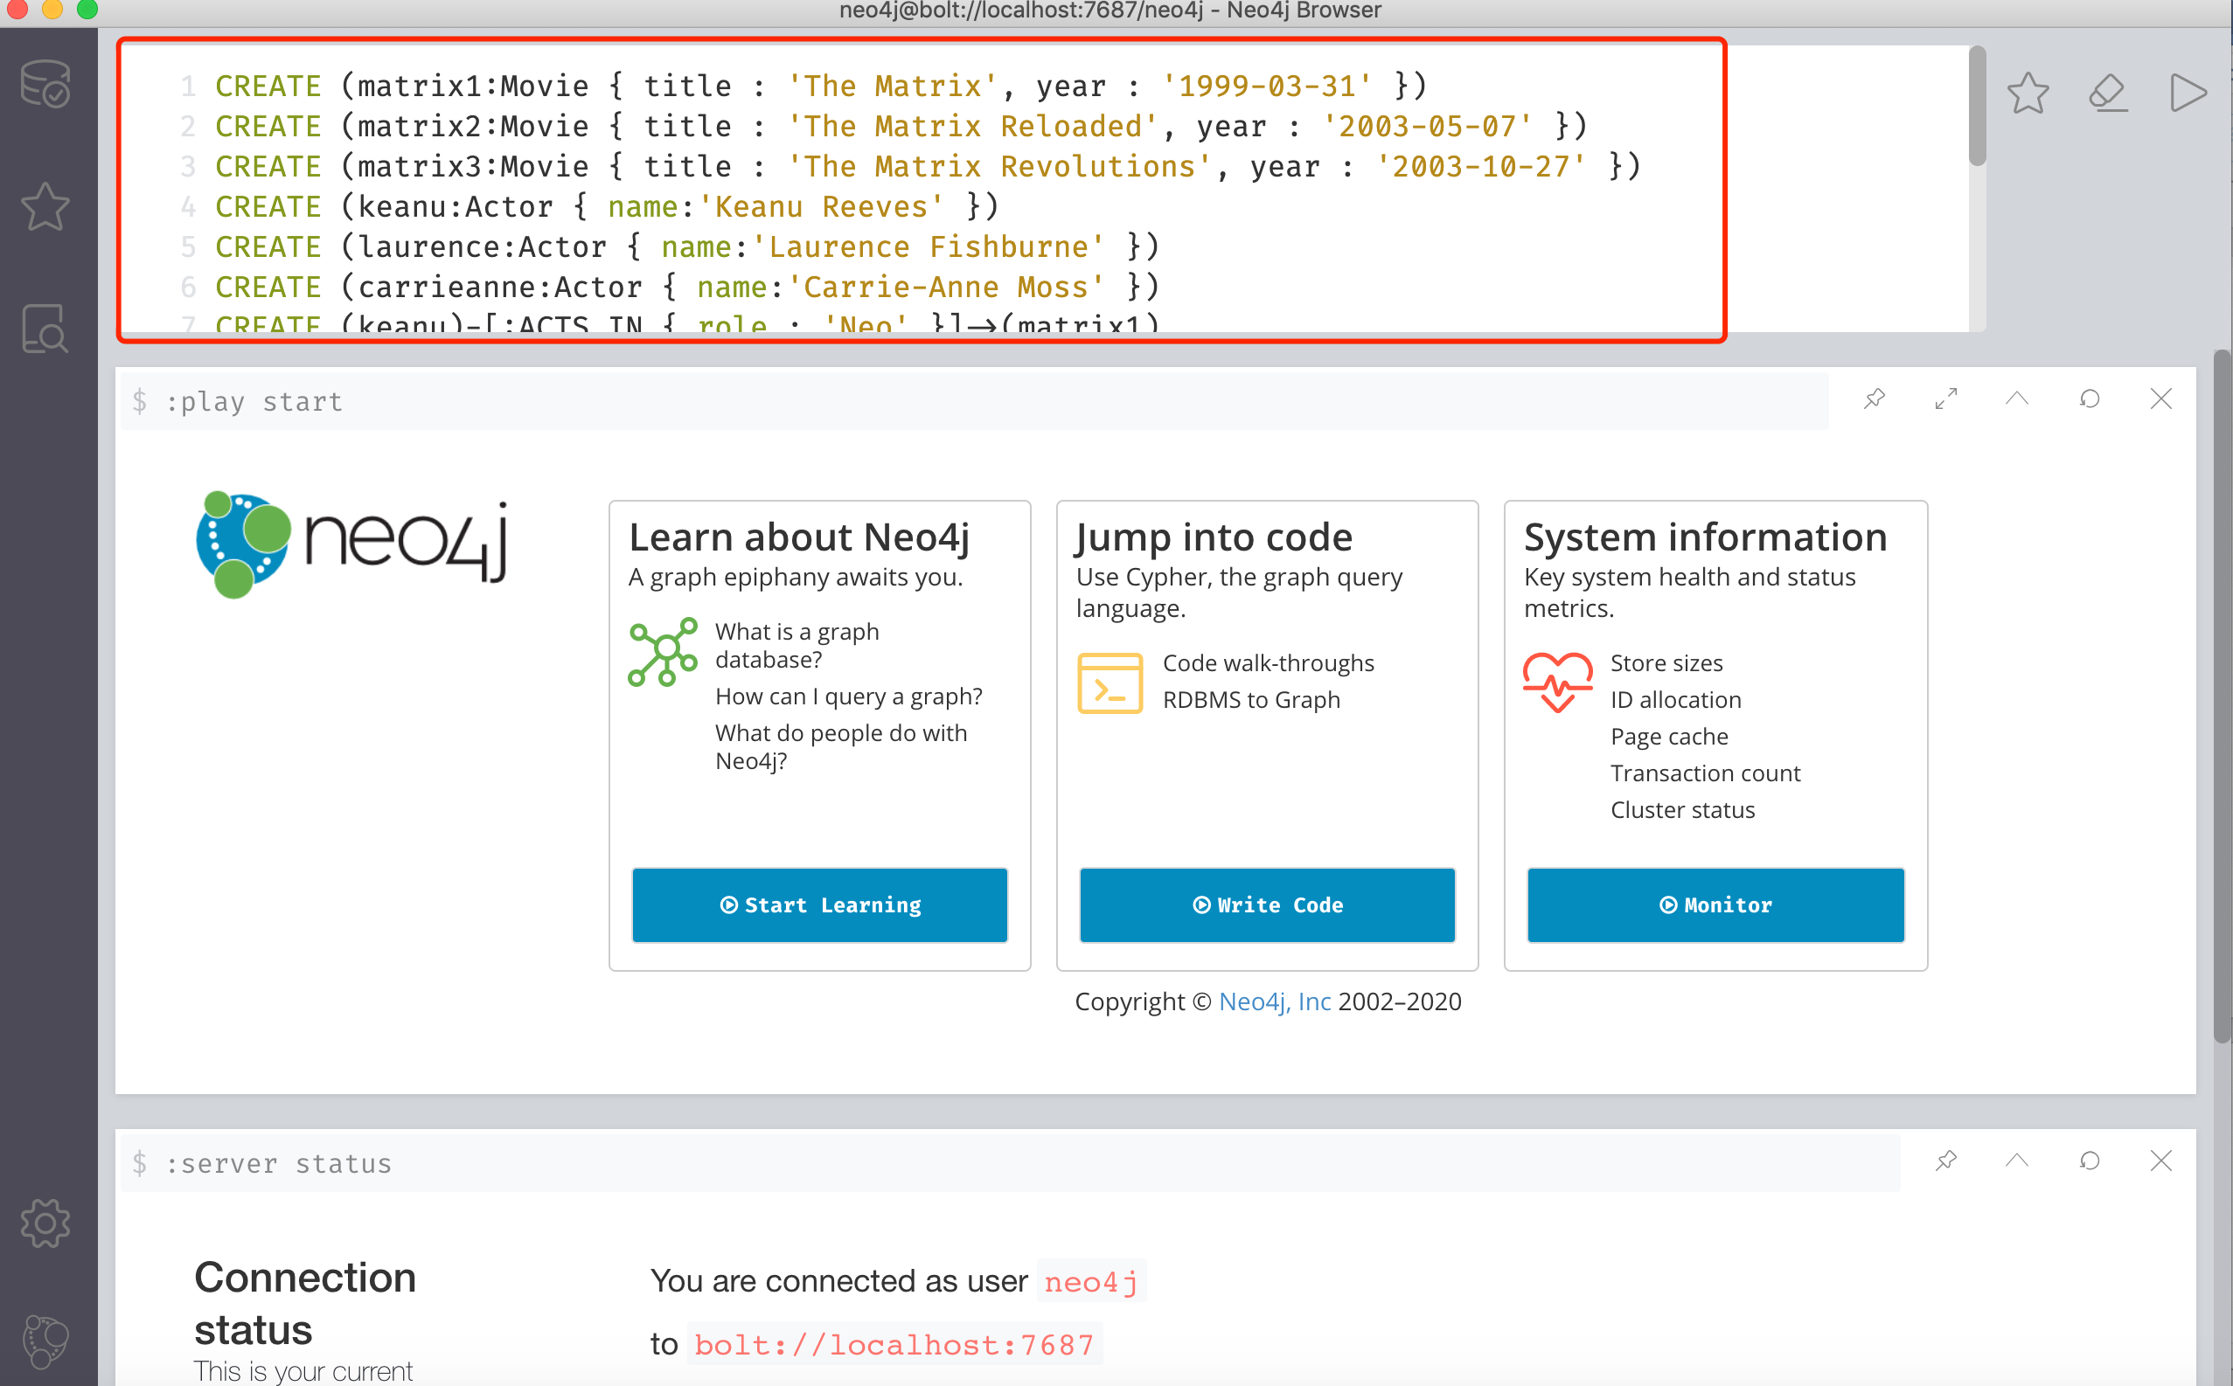

Enter the given code to CREATE movie graph:

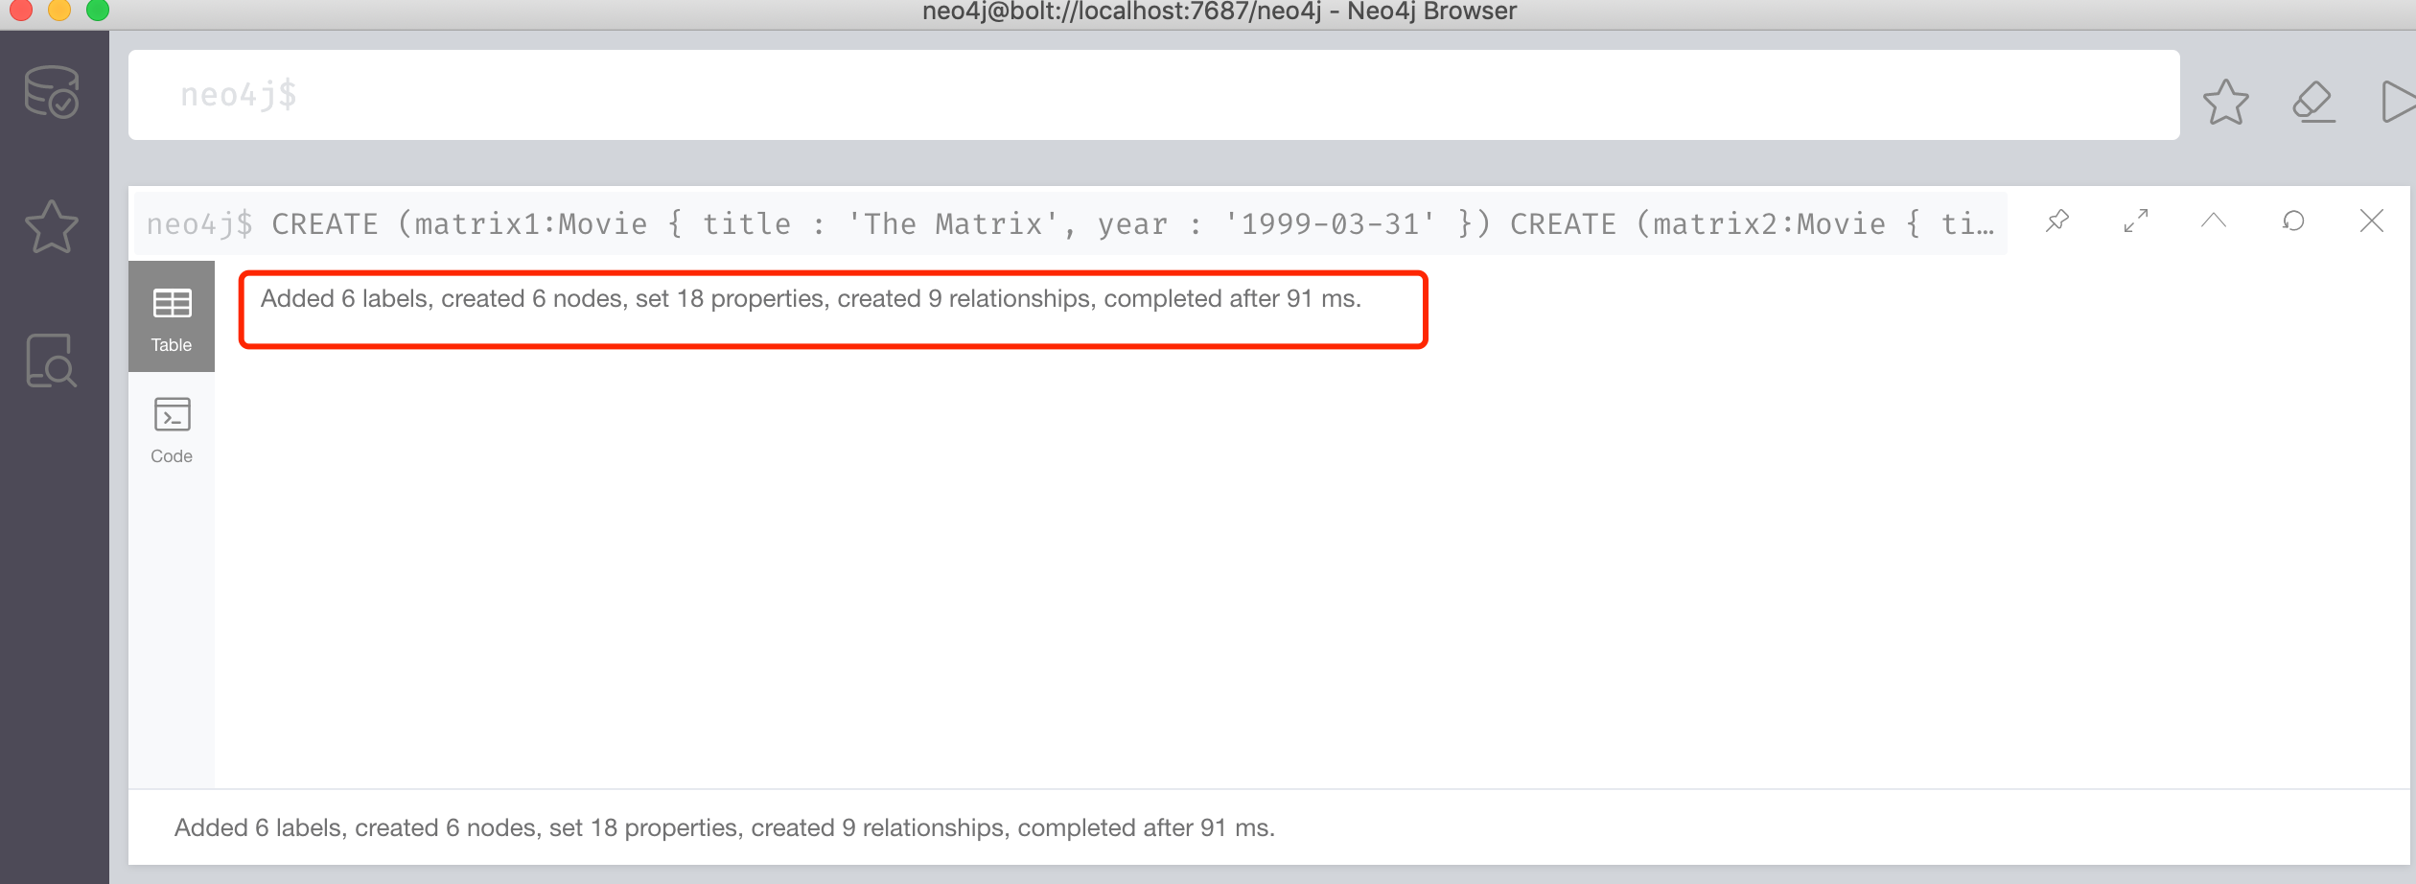

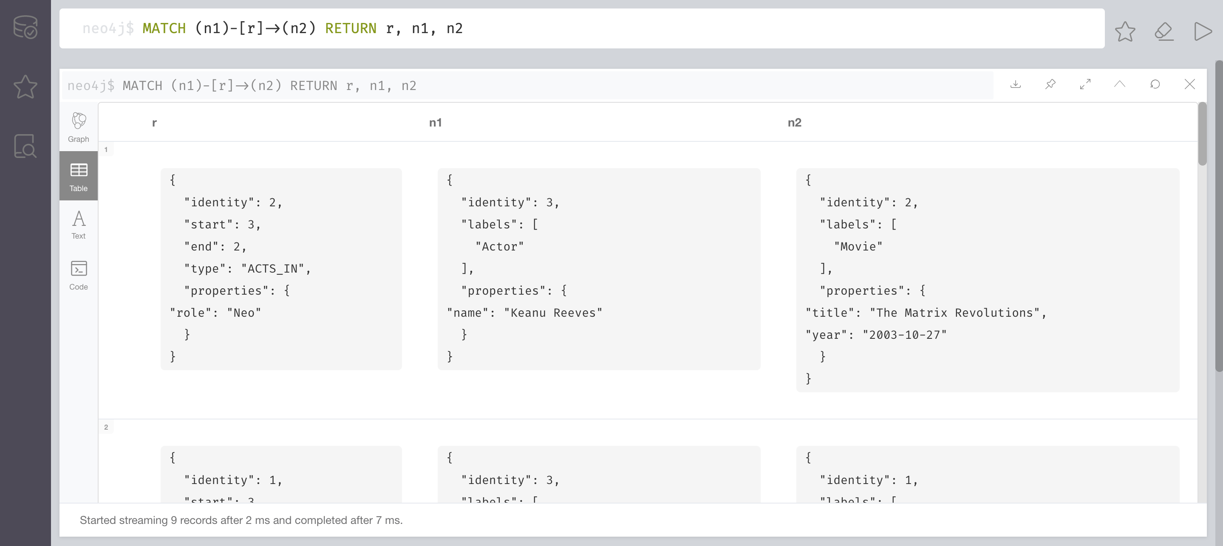

Visualize the relationship: MATCH (n1)-[r]->(n2) RETURN r, n1, n2

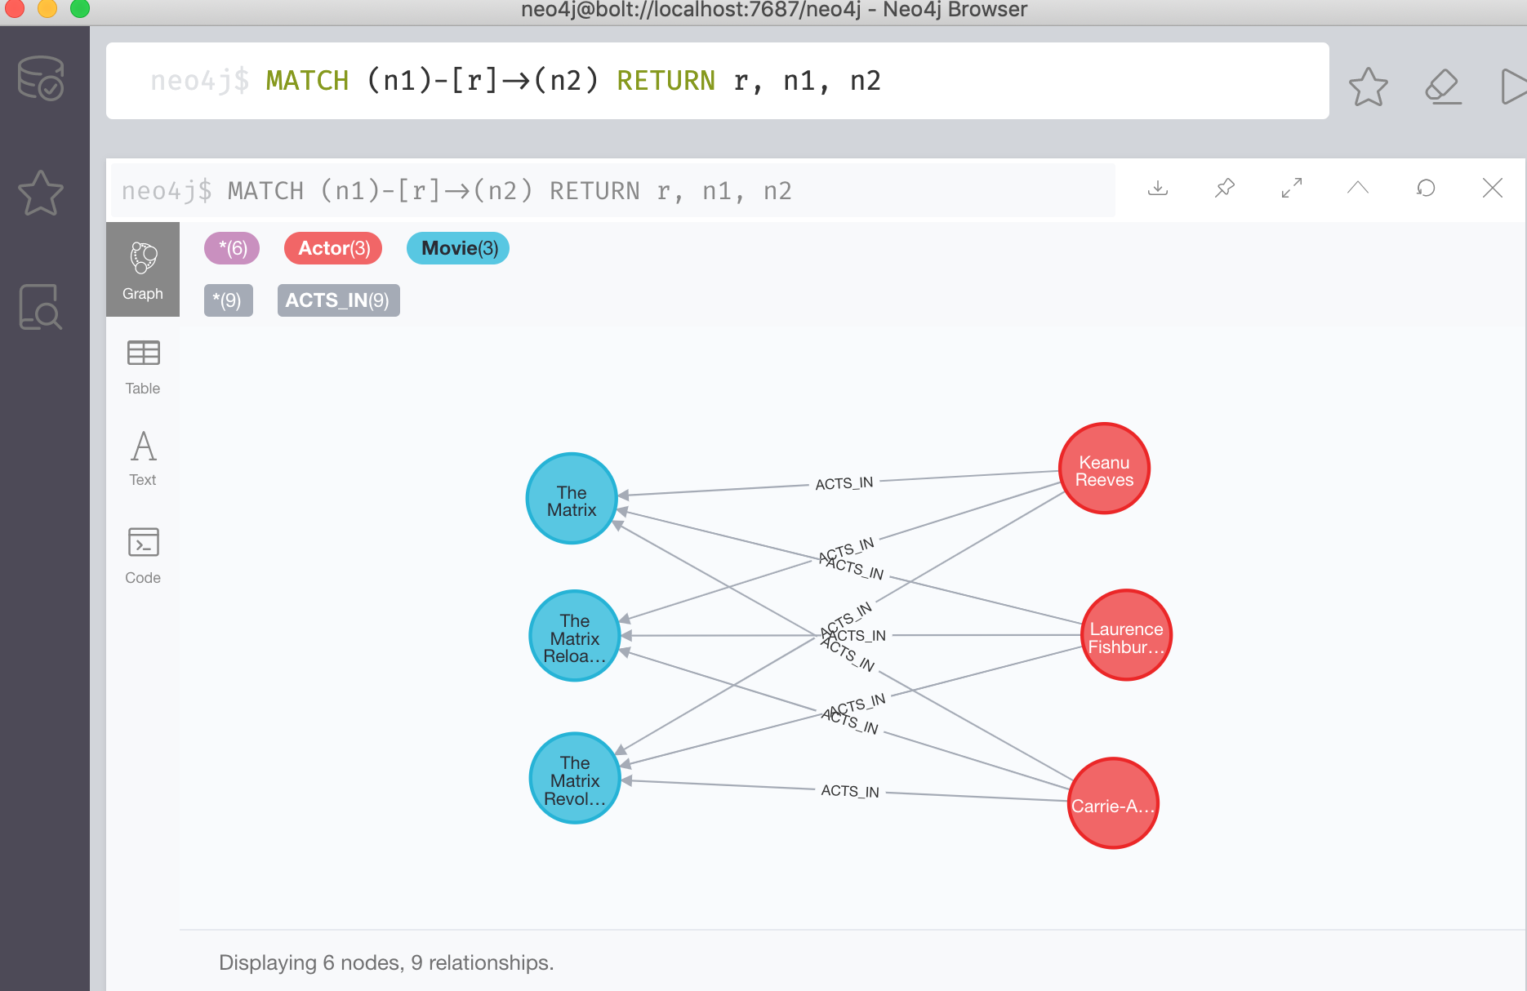

**Problem 3:**

Keanu Reeves acted in the movie “John Wick” which is not in the database. That movie was directed by Chad Stahelski and David Leitch. Cast of the movie included William Dafoe and Michael Nyquist. Add all of those people and the roles they played in this movie to the database using JAVA REST API or one of other RESTful APIs for Neo4J in a language of your choice. Demonstrate that you have successfully brought data about John Wick movie into the database. You can use Cypher Browser or any other means.

**Total points: 20**

Put all your steps and screen captures here.

Creaate the movie “John Wick” by adding director and actor name

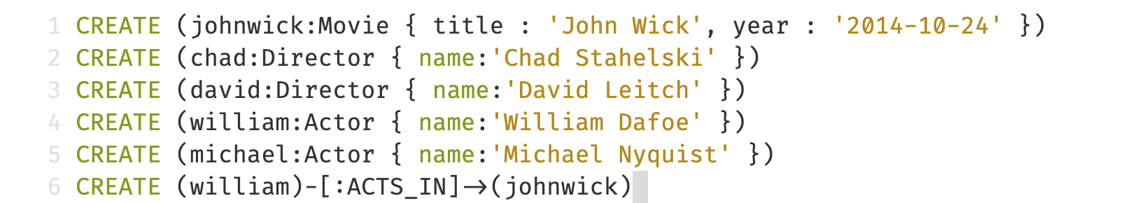



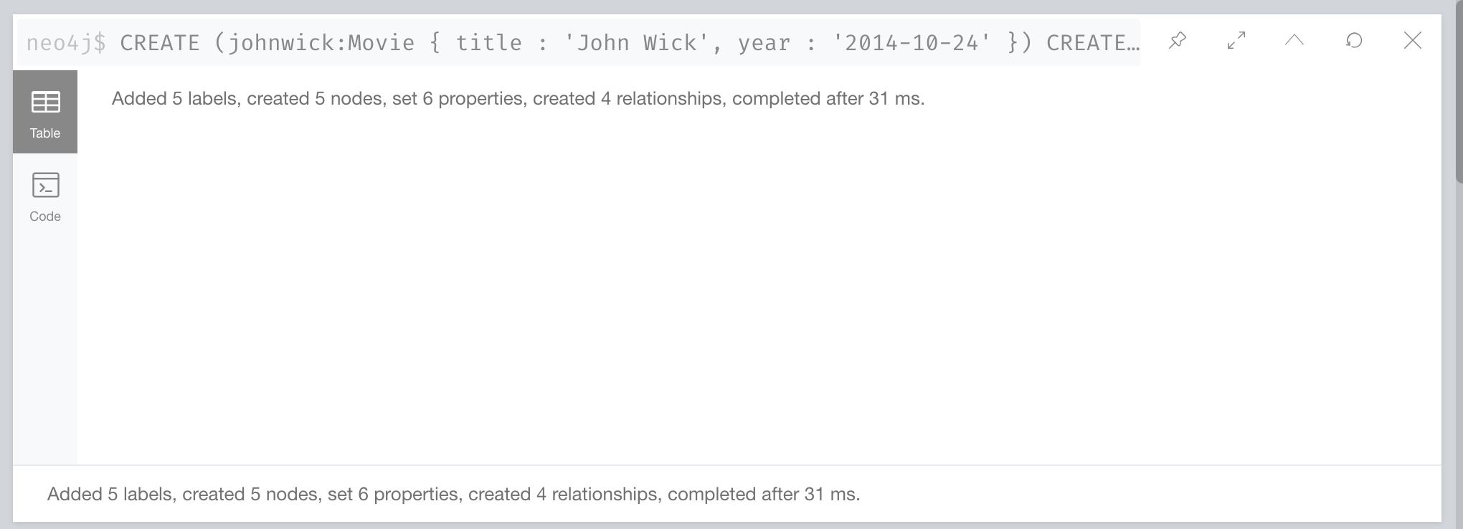

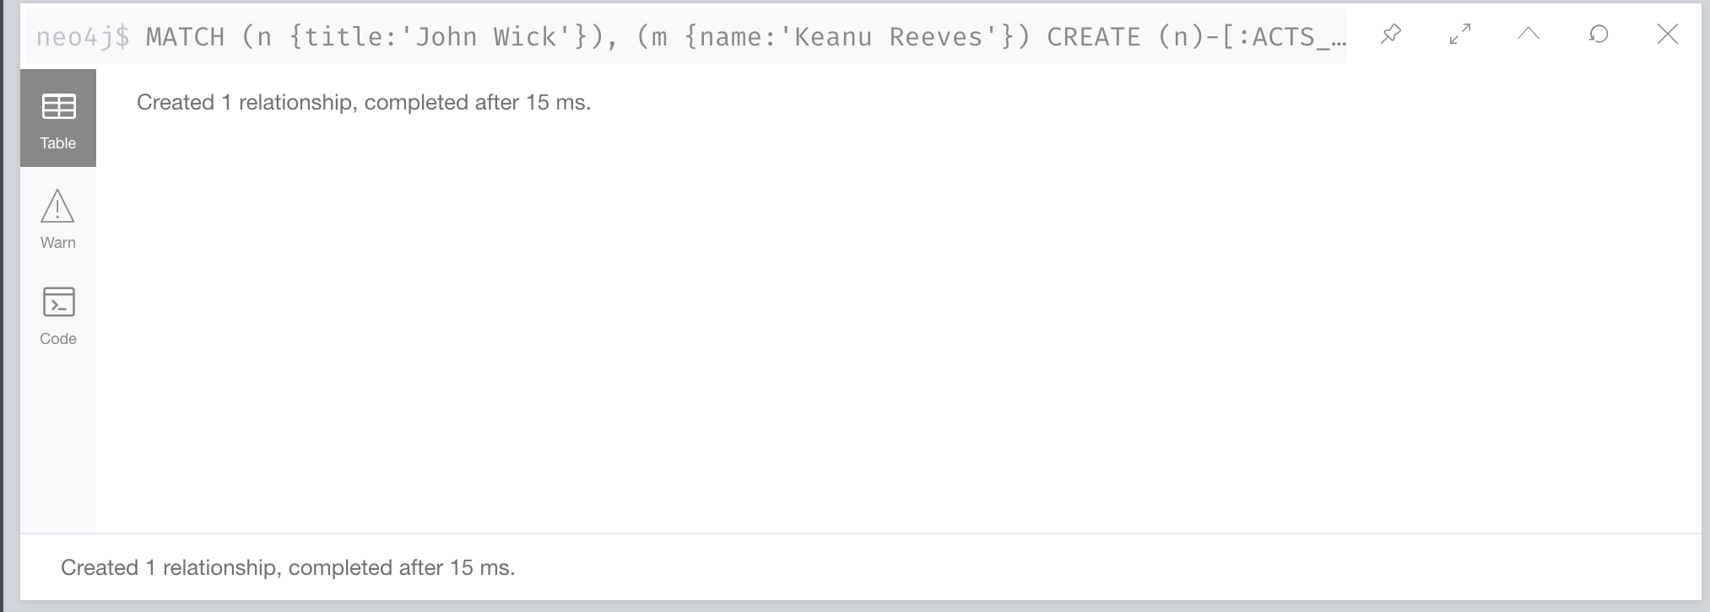 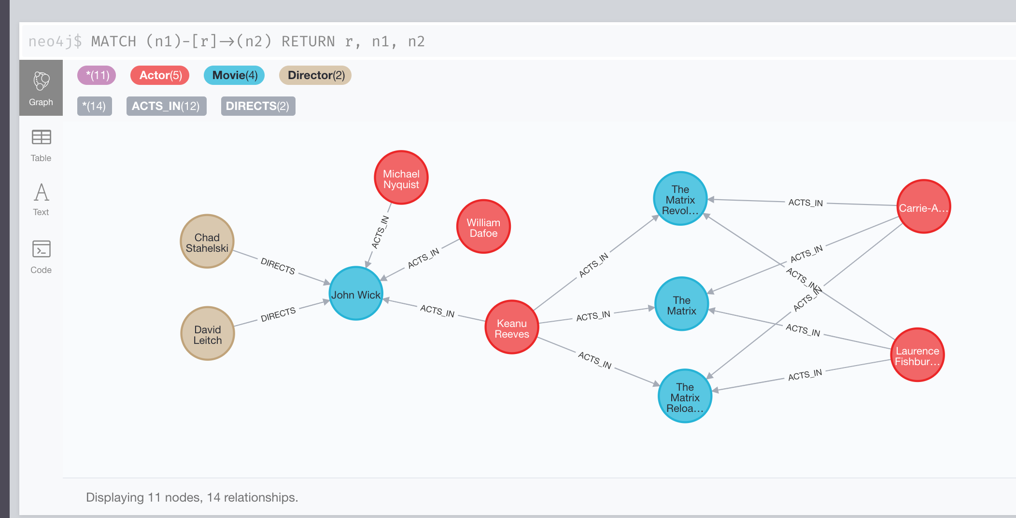

**Problem 4:**

Find a list of actors playing in movies in which Keanu Reeves played. Find directors of movies in which K. Reeves played.

**Total points: 15**

MATCH (keanu:Actor {name: "Keanu Reeves"})-[:ACTS_IN]->(keanuReevesMovies)

RETURN keanu, keanuReevesMovies



We can see all the Keanu Reeves movies:

1. 'The Matrix',

2. 'The Matrix Reloaded'

3. 'The Matrix Revolutions'

4. ‘John Wick’

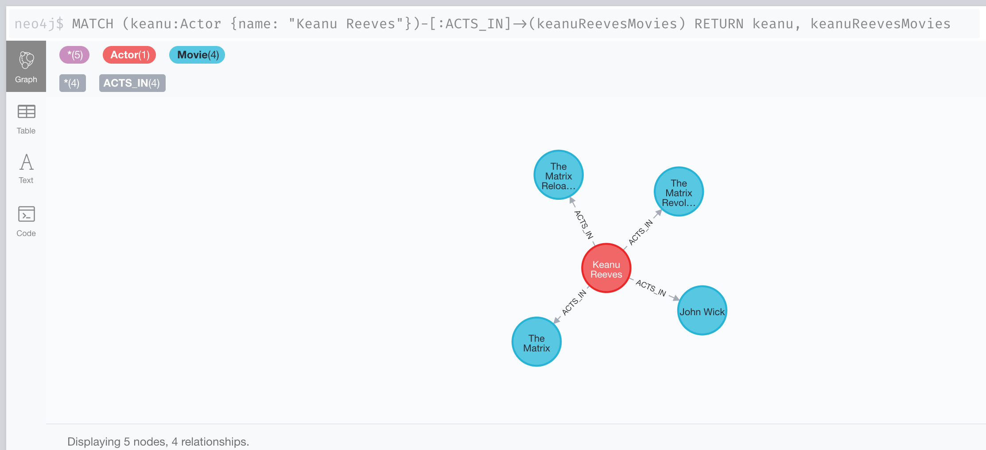



The Directors we have are Chad Stahelski and David Leitch from movie ‘John Wick’:

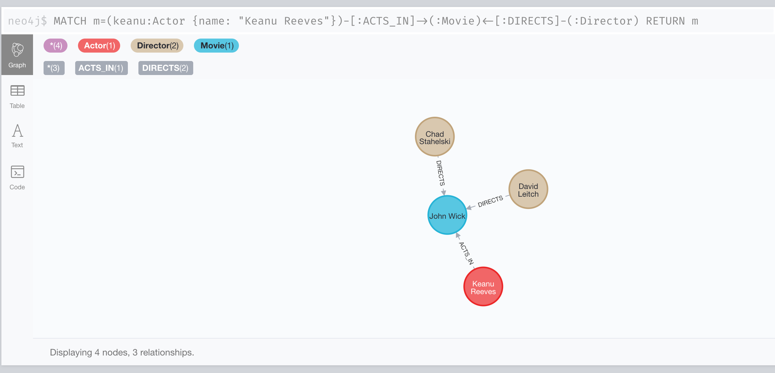

**Problem 5:**

Find a way to export data from Neo4j into a set of CSV files. Delete your database and demonstrate that you can recreate it by loading those CSV files.

**Total points: 15**

Click “export CSV” for each created relationship and save each of them as CSV files.

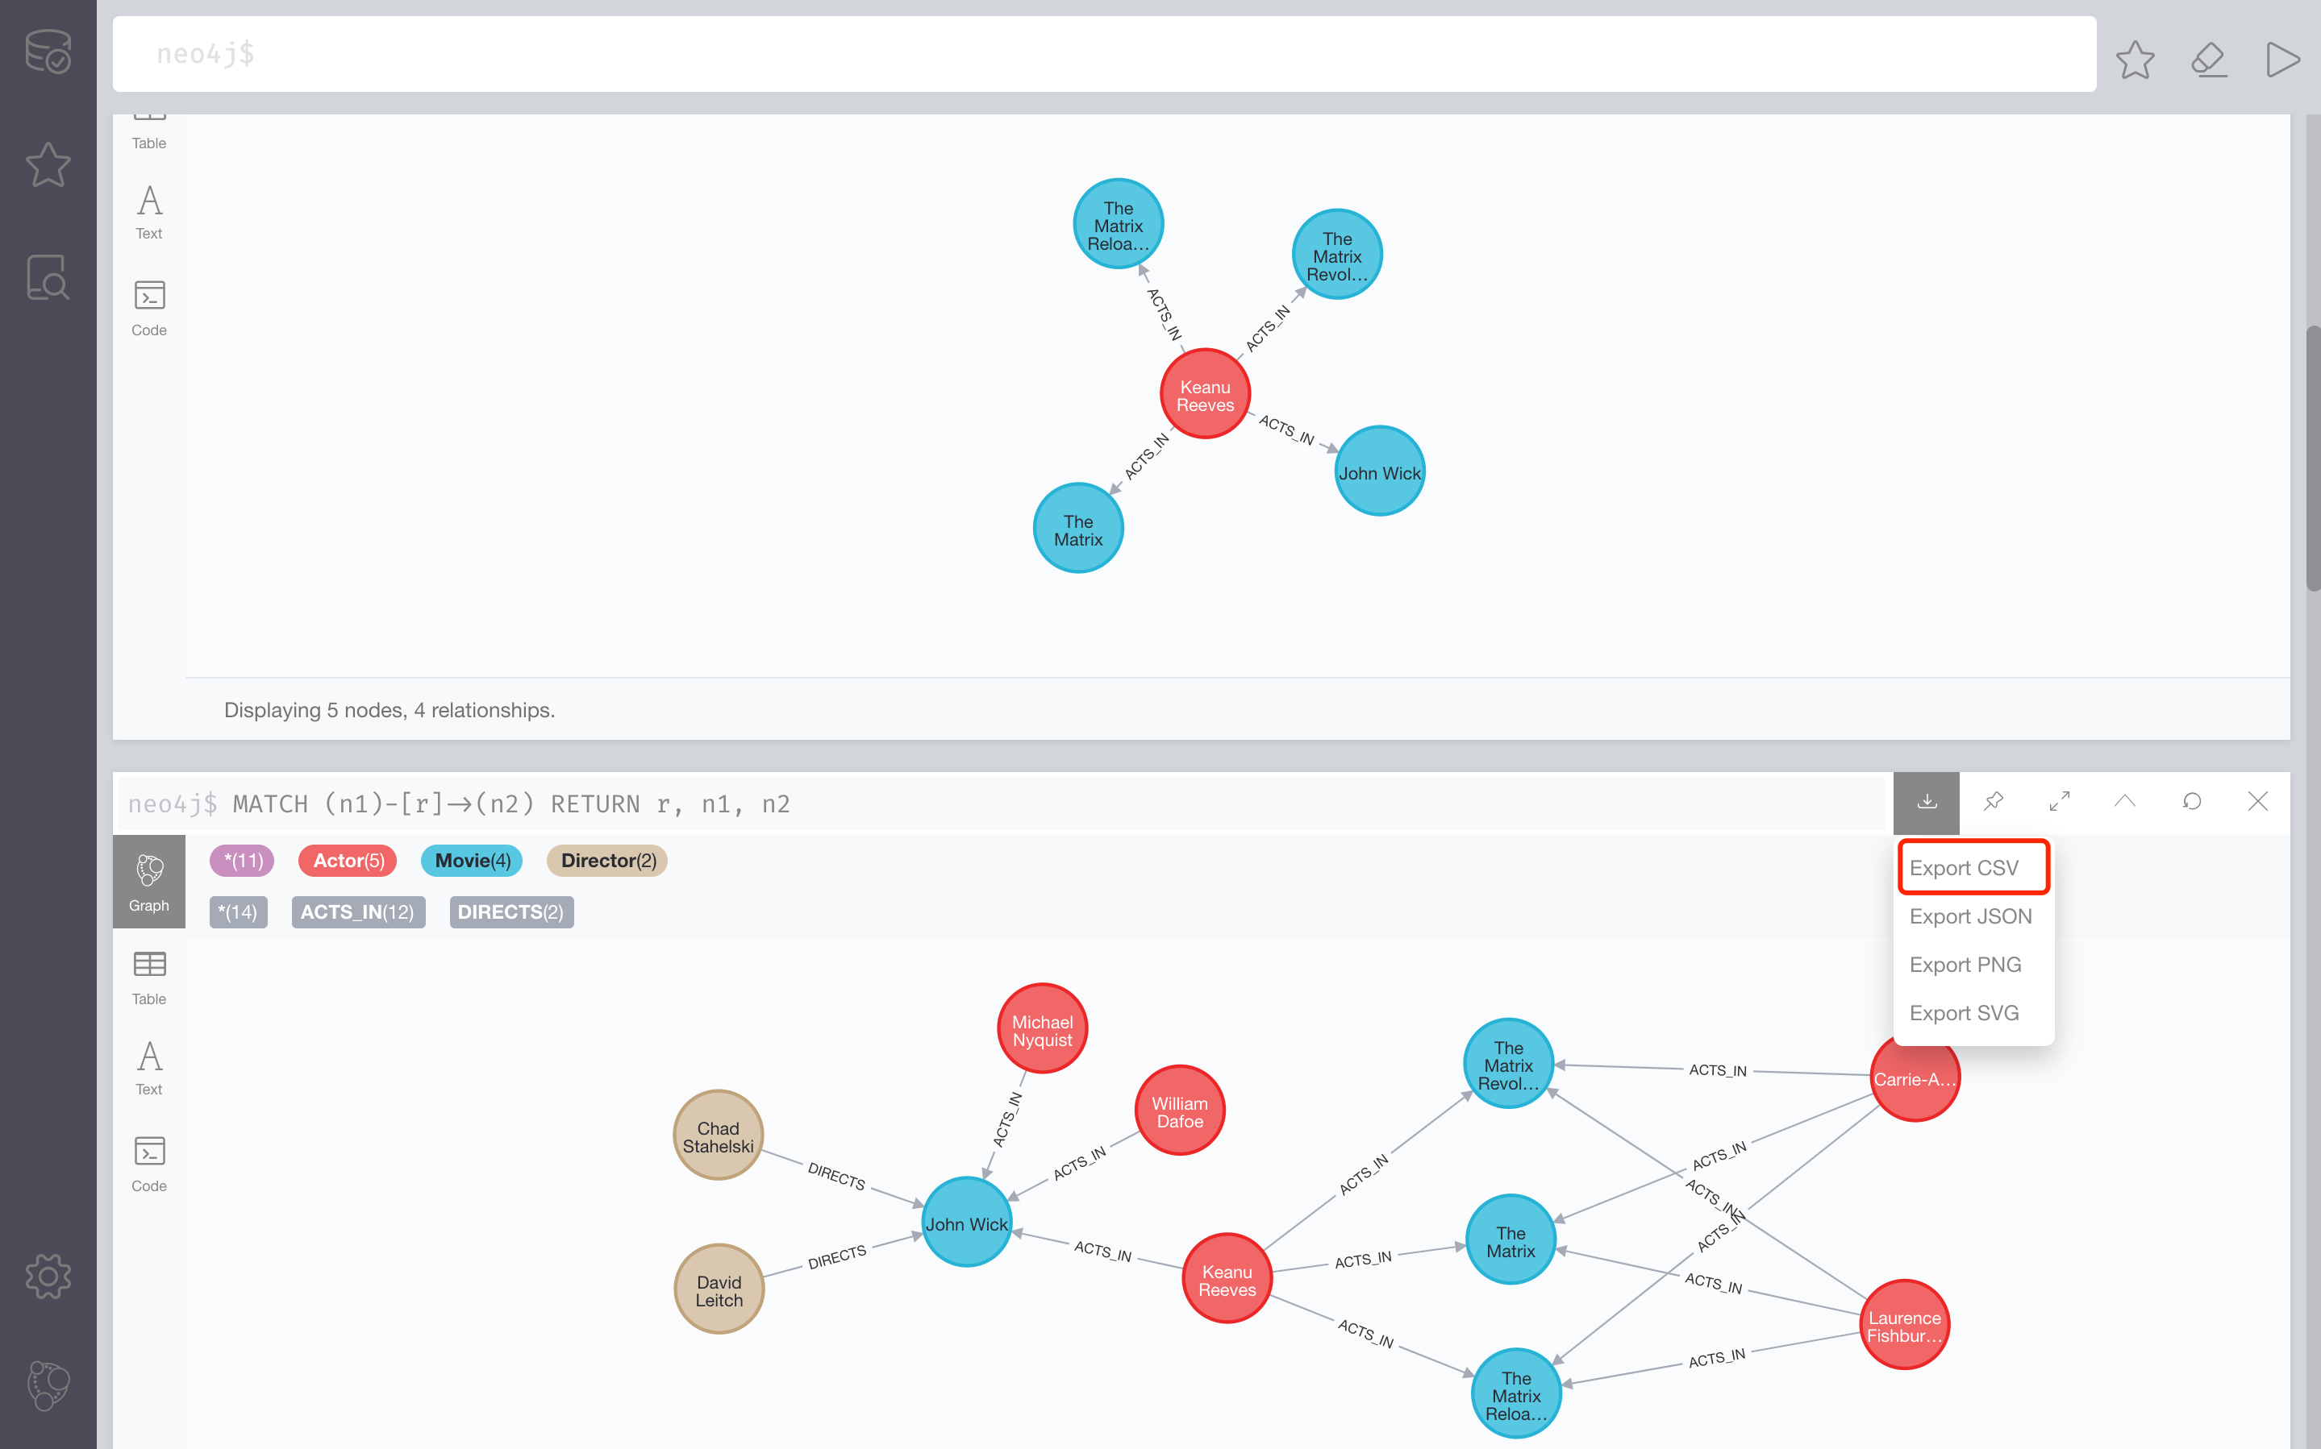

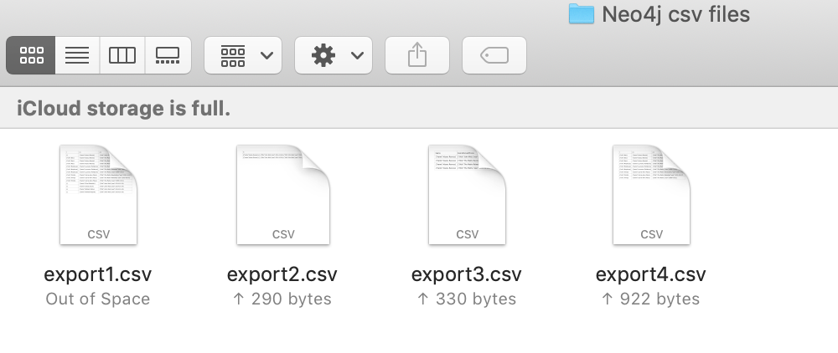

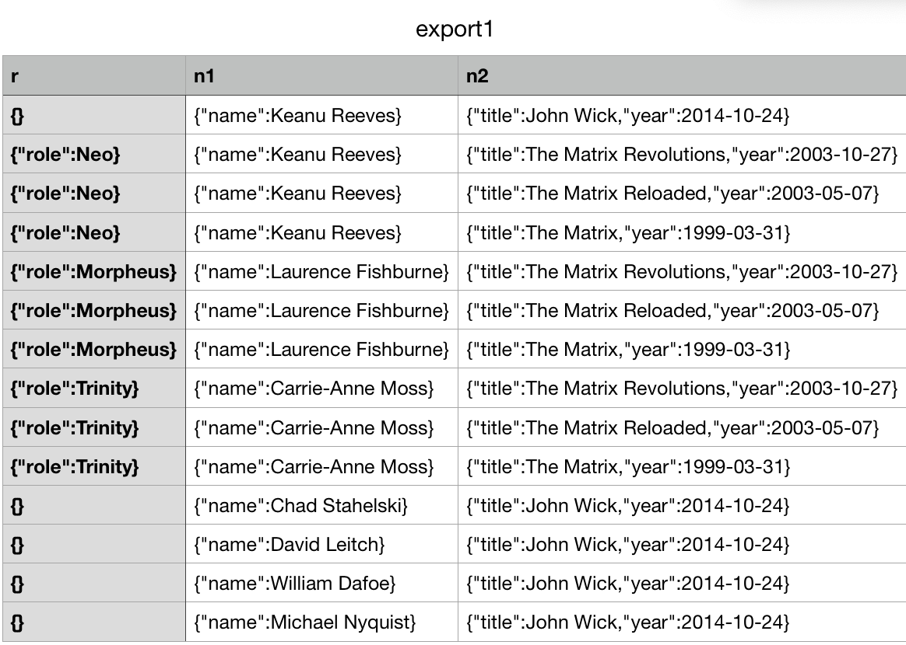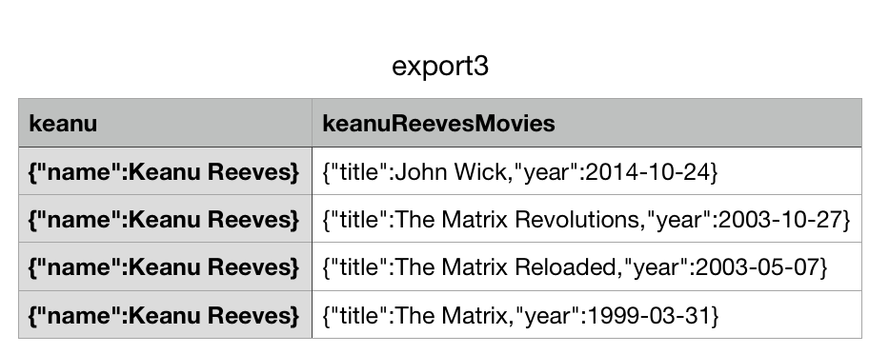

We can delete the database by click the remove button from Neo4j homage

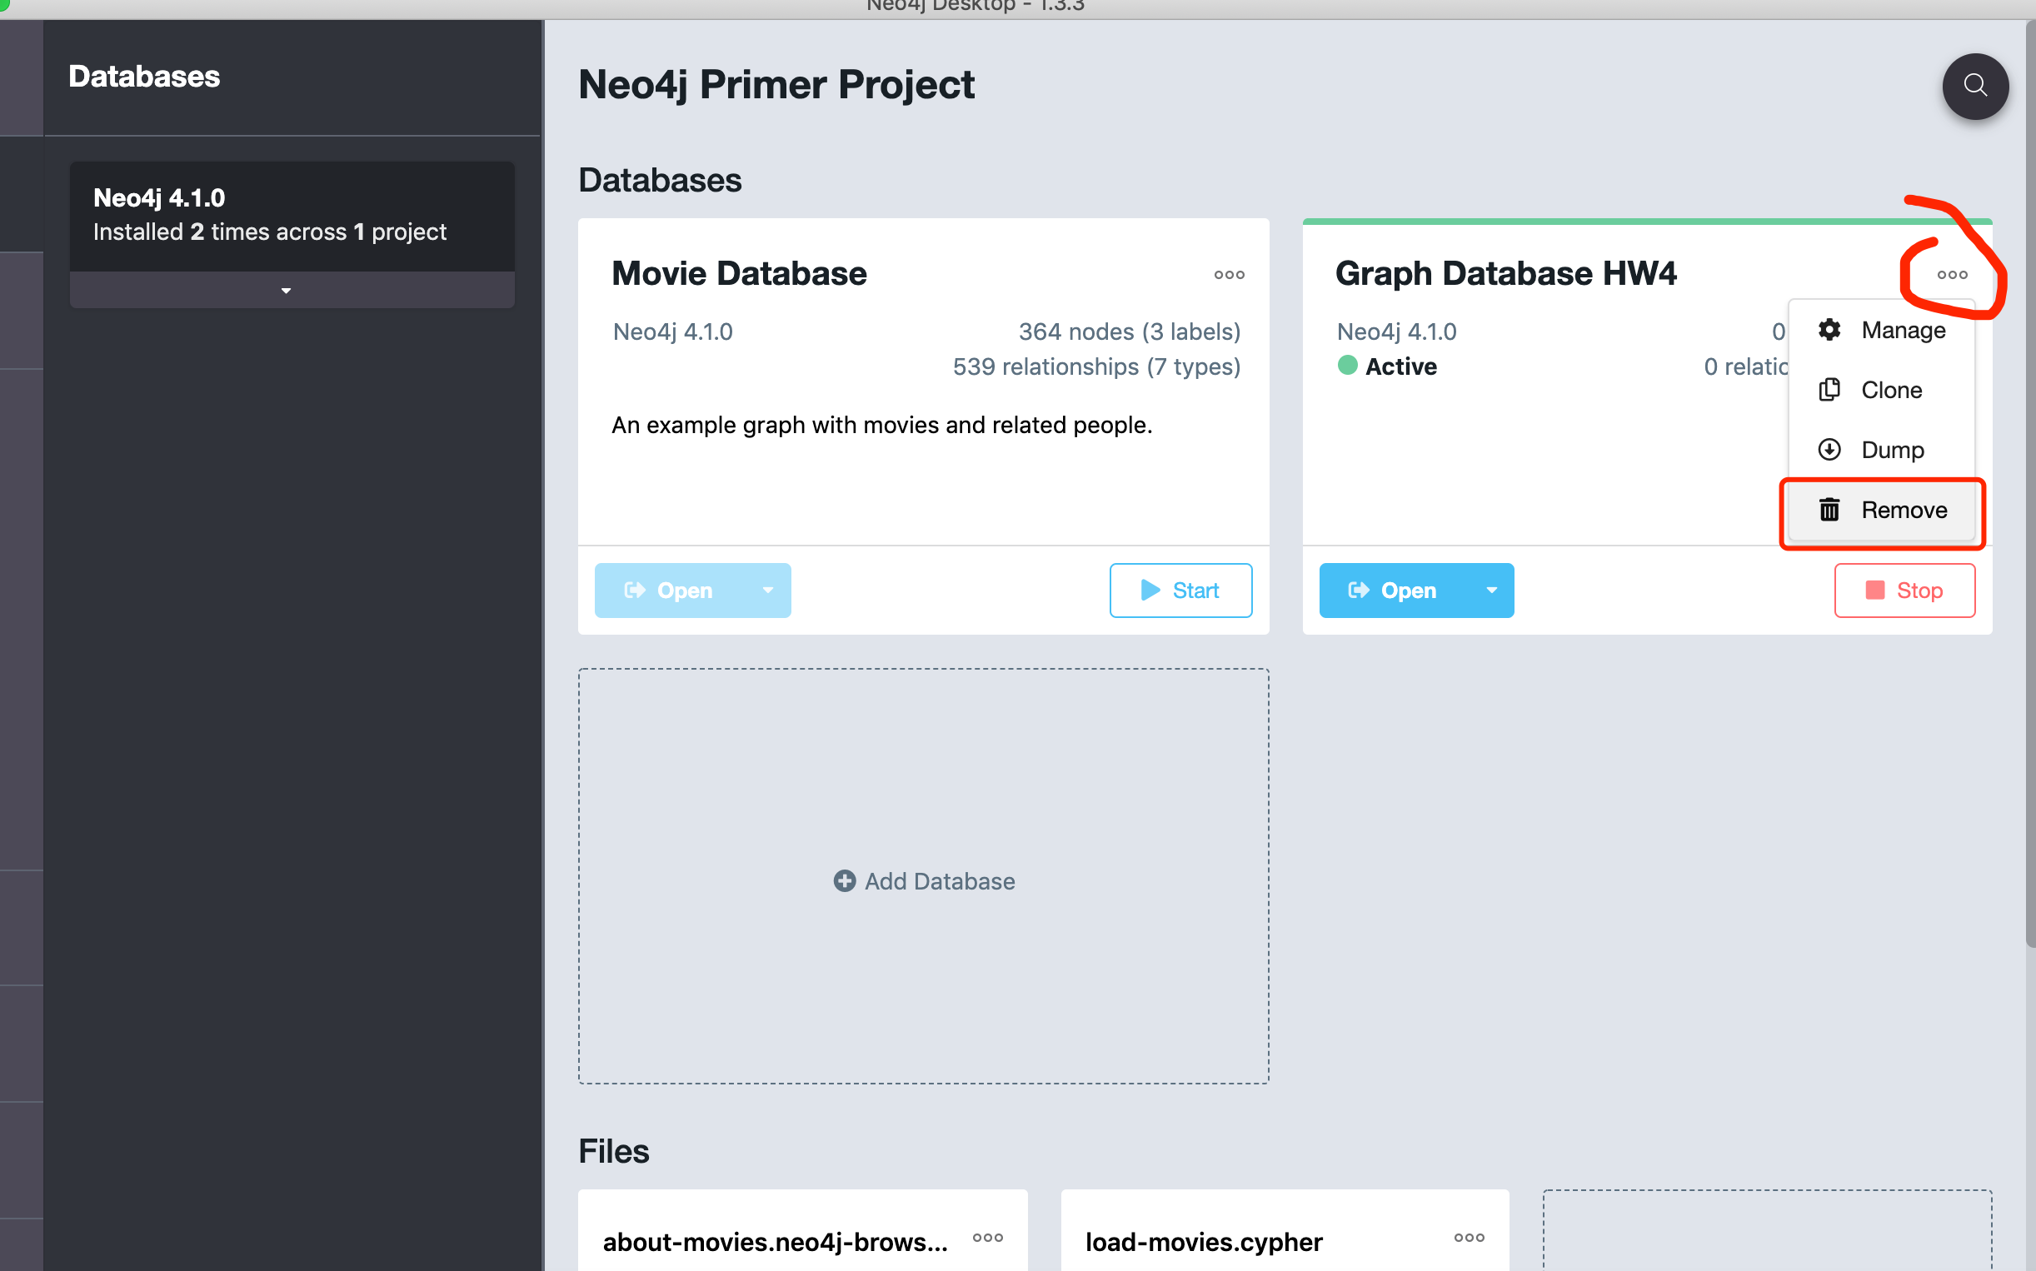

Recreate a new one:

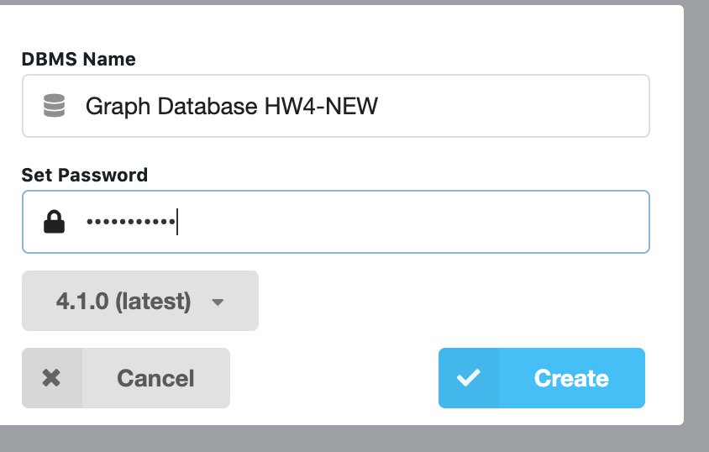 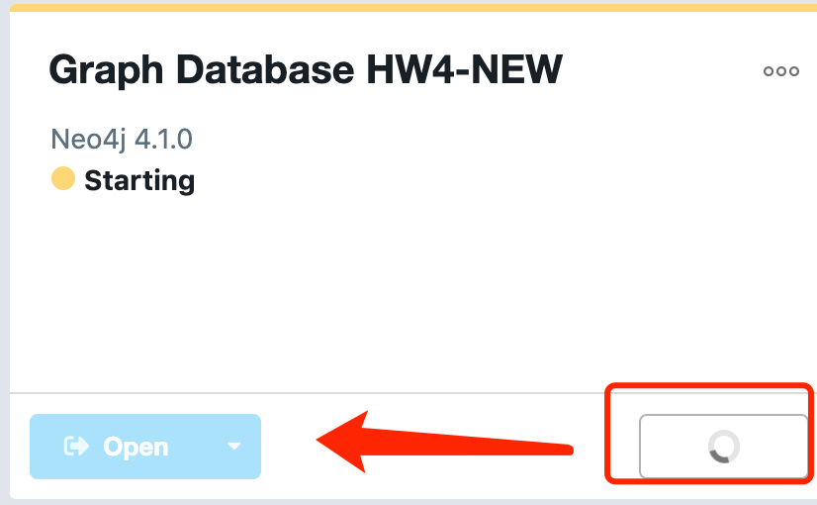 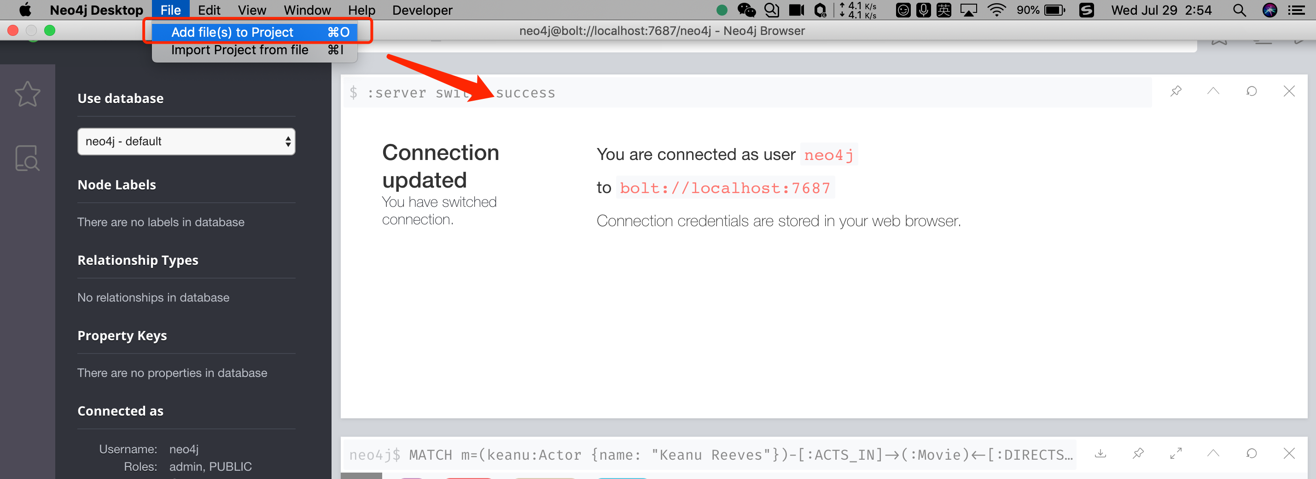

Click file - Add file

Select all saved CSV files and open them: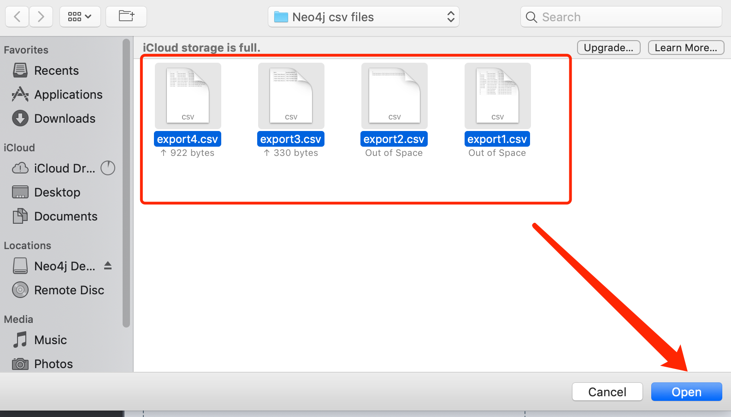

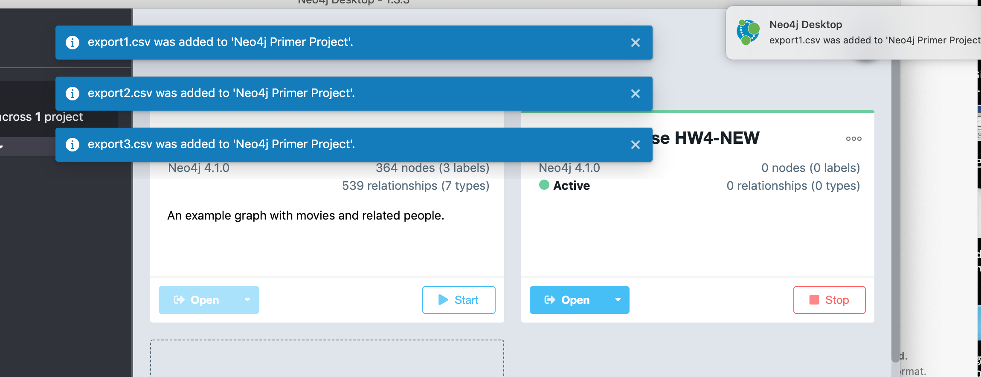

**Problem 6:**

Cloud Based Neo4j Sandbox. Go to [https://neo4j.com/sandbox](https://na01.safelinks.protection.outlook.com/?url=https%3A%2F%2Fneo4j.com%2Fsandbox&data=02%7C01%7Cs.shevchenko%40northeastern.edu%7Ce38b3ba669a142f3937f08d696afb373%7Ca8eec281aaa34daeac9b9a398b9215e7%7C0%7C0%7C636862078740140772&sdata=1oJNnWWZjFXOsdOxy4iF%2F29e7TK5gAigkQnk6ZHA6ZY%3D&reserved=0)  and when prompted choose "NEW Neo4j <latest.version> release - Blank Sandbox".   You can choose any Neo4j Sandbox with data in it to play around with if you want to.  You can also create more than one Sandbox, though they do have an expiration date. Provide all steps of your development!

**Total points: 20**

Put all your steps and screen captures here.





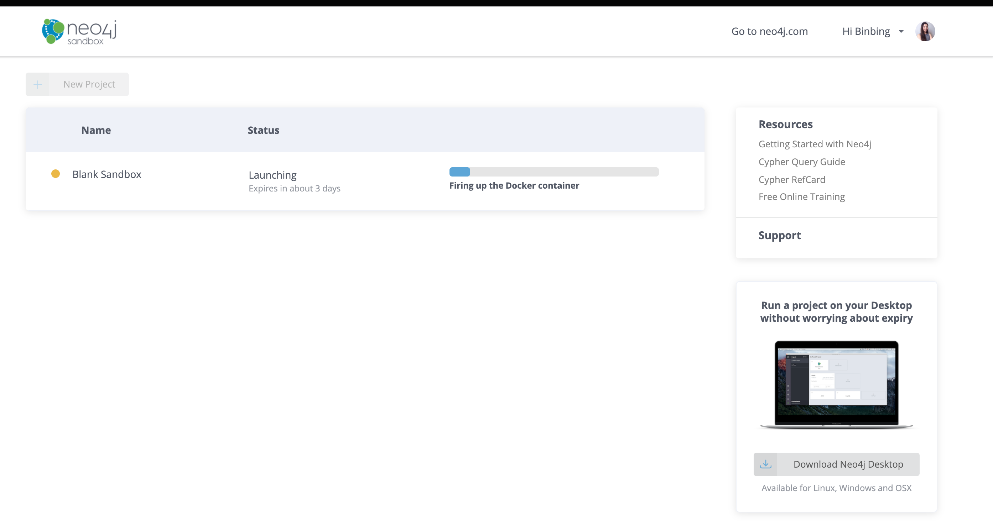

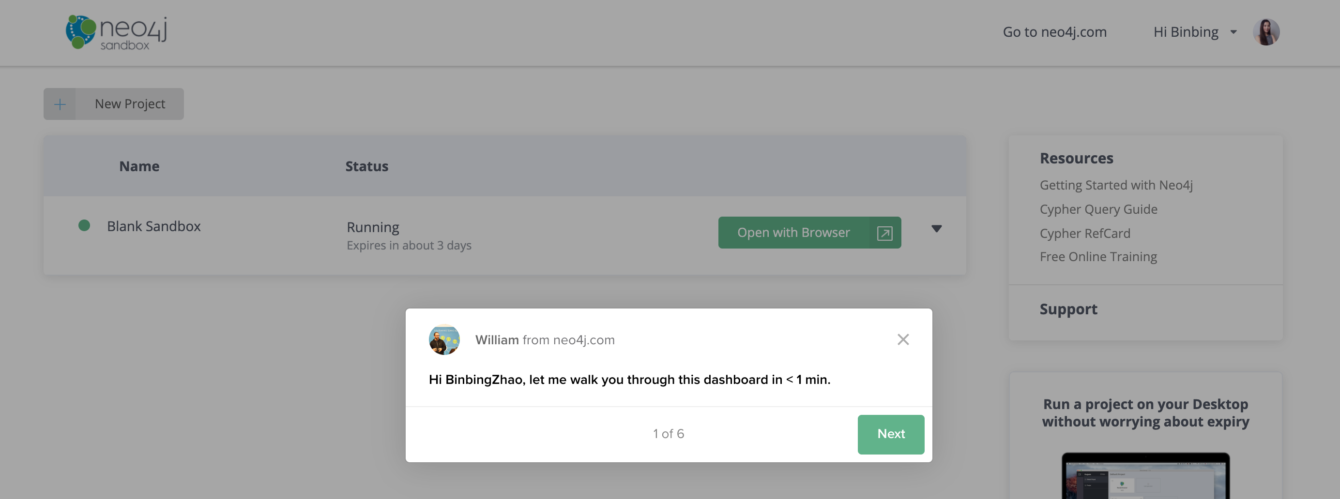

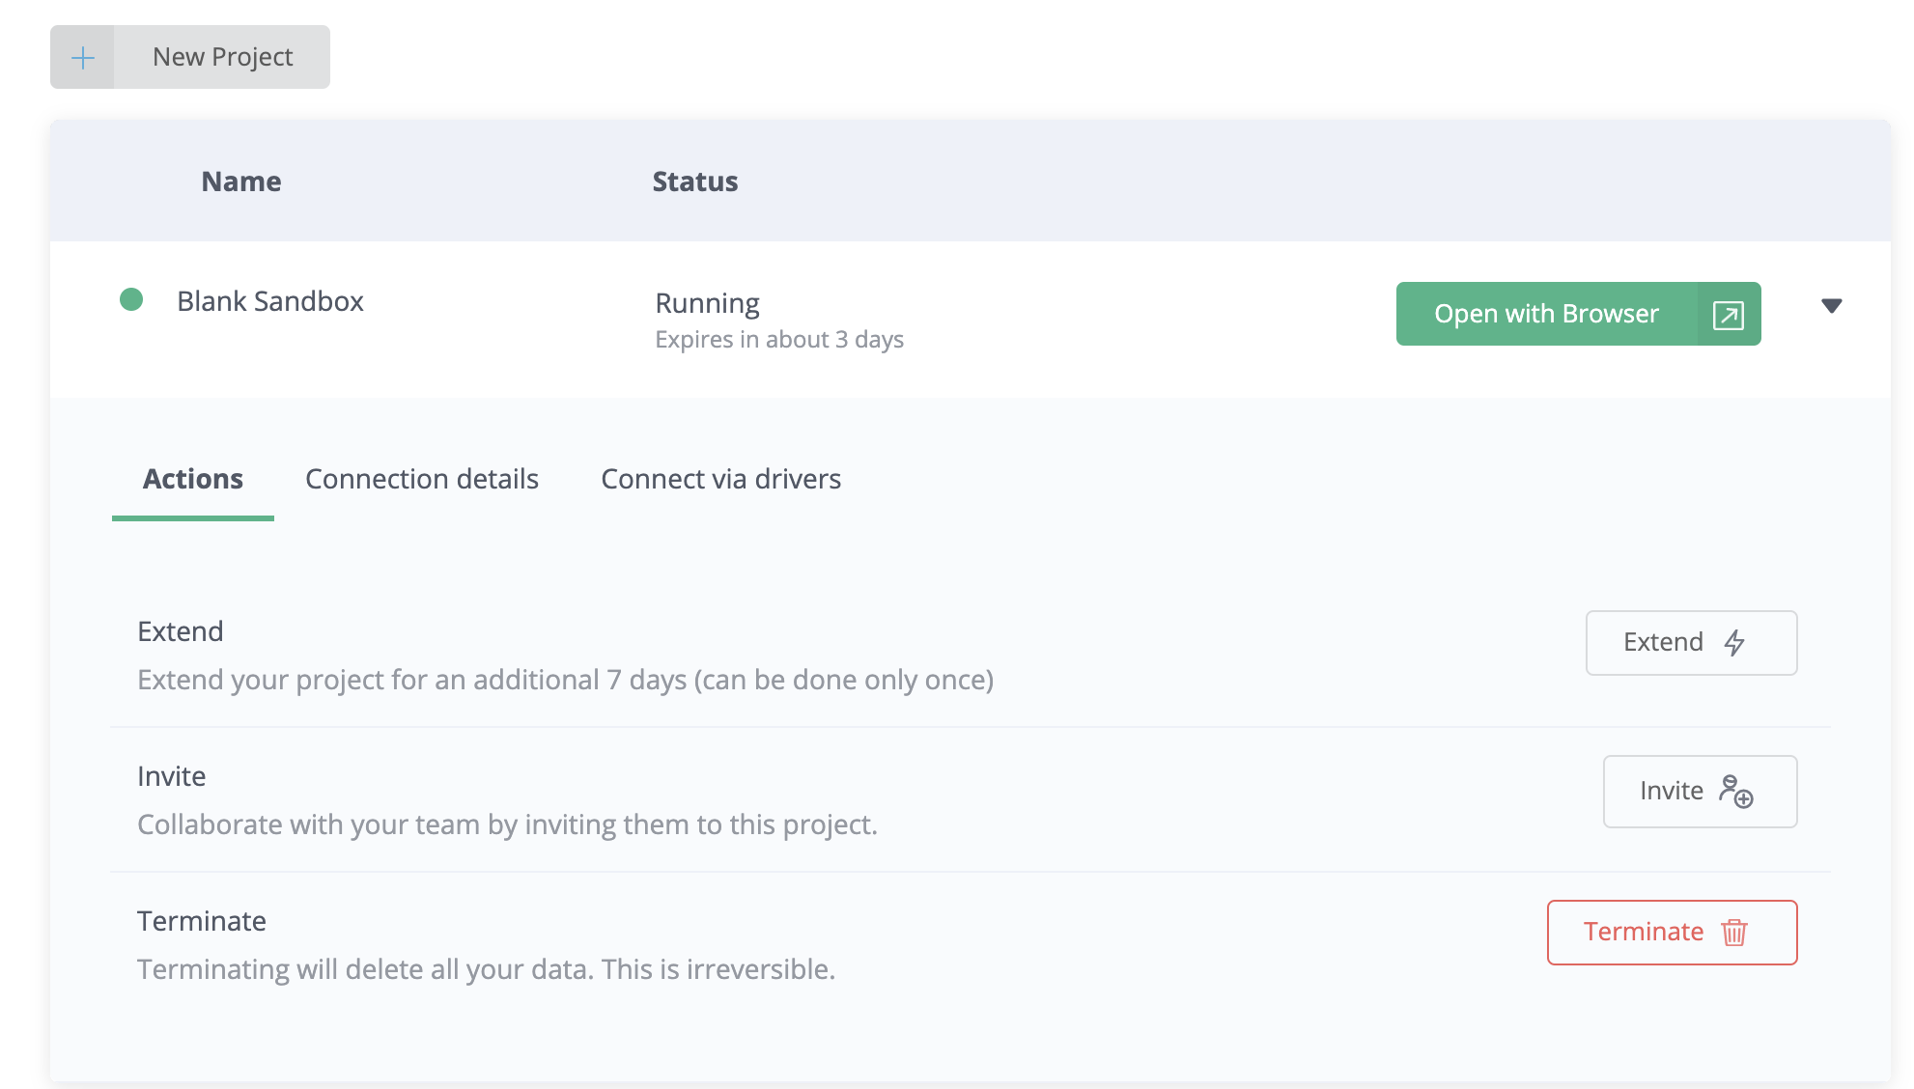

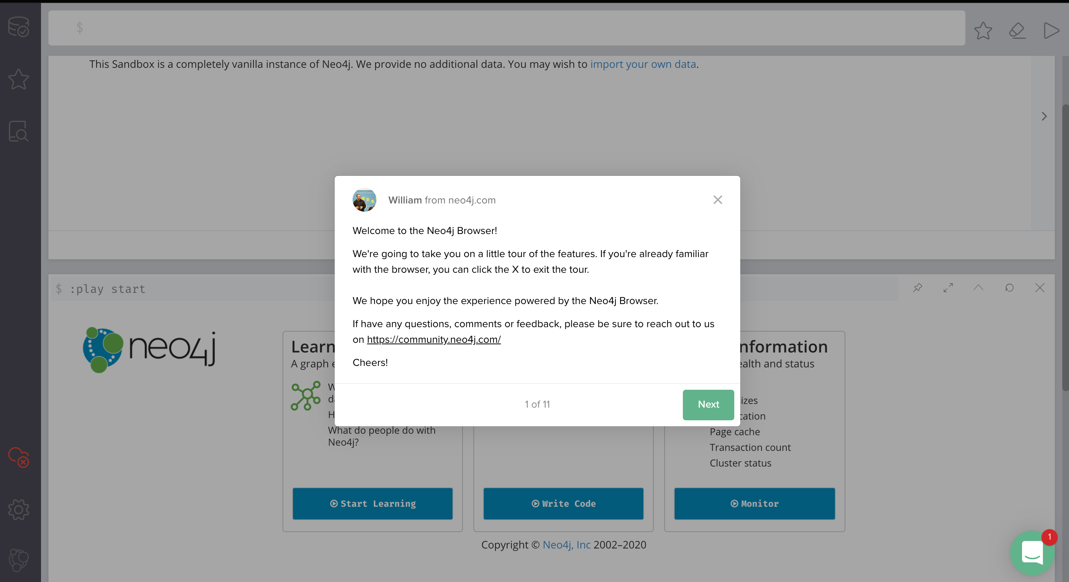

We use the same movie code on the sandbox browser: MATCH (n)-[r]->(movie) RETURN r, n, movie

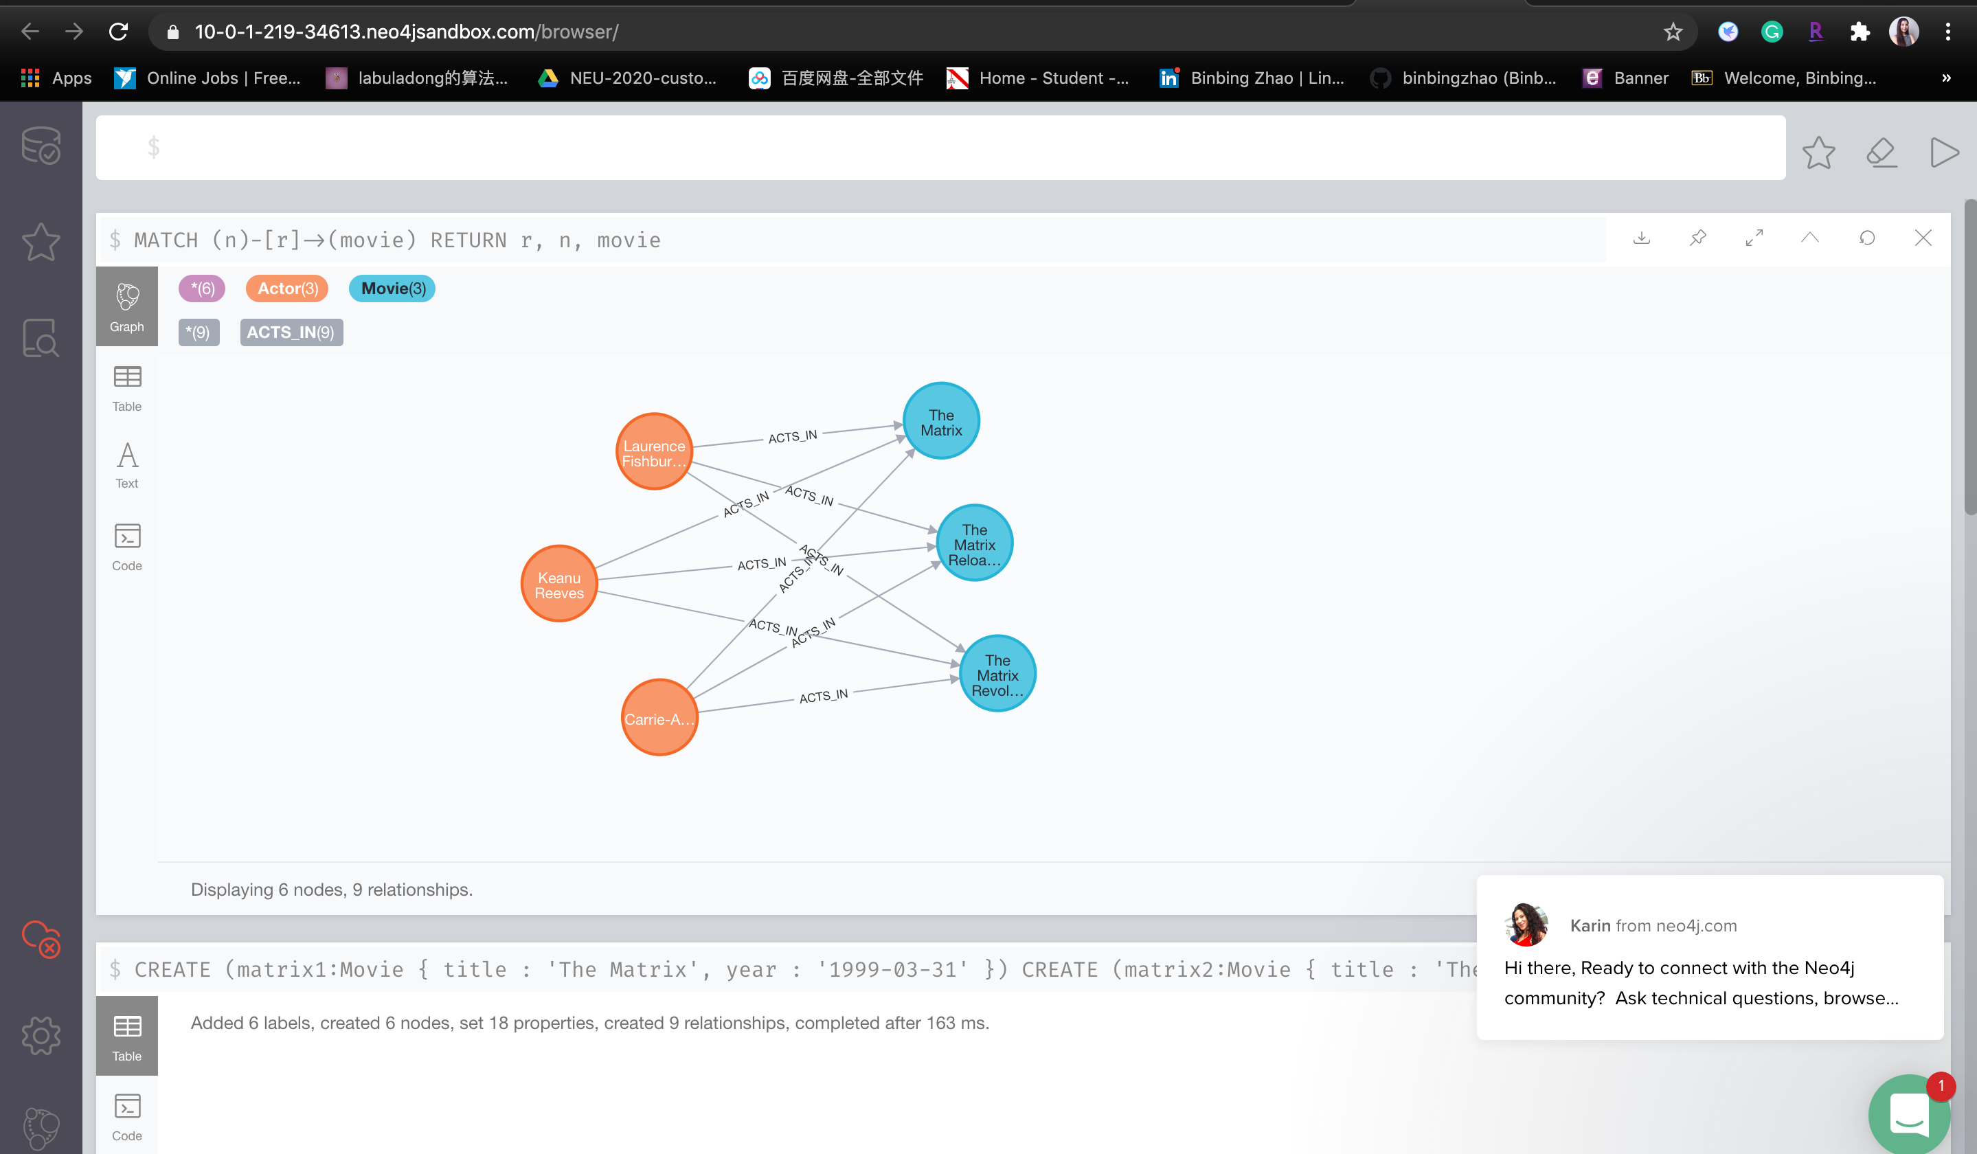

Trying other projects:



